Running *head:* Landscape controls on stream signatures

Landscape controls on stream signatures: the forest edge as the stream boundary for terrestrial food webs

## Jeffrey D. Muehlbauer1, 2, Patrick A. Clay1, 3, Klement Tockner4, 5, and Martin W. Doyle6

1Curriculum for the Environment & Ecology, University of North Carolina at Chapel Hill, Chapel Hill, North Carolina, USA

2US Geological Survey, Grand Canyon Monitoring and Research Center, Flagstaff, Arizona, USA; Email: [jmuehlbauer@usgs](mailto:jeffreym@unc.edu).gov

3Department of Biosciences, Rice University, Houston, Texas, USA

4Leibniz-Institute of Freshwater Ecology and Inland Fisheries (IGB), Berlin, Germany

5Institute of Biology, Freie Universität Berlin, Berlin, Germany

6Nicholas School of the Environment, Duke University, Durham, North Carolina, USA

Abstract

Ecological resource subsidies of energy and nutrients can be an important, high-magnitude component of recipient food webs across a range of ecosystems. However, relatively few studies have documented the distance these subsidies can travel through ecosystems: if a subsidy’s effect is entirely localized at ecotones or if it is more perfuse throughout the landscape. Fundamentally, the spatially-extensive transmission of subsidies challenges traditional notions of the borders of ecosystems, suggesting both that these borders are more open than generally acknowledged, and that the food web boundary of an ecosystem (the distance where a subsidy is no longer present) may differ from other ecological borders that are based on landscape structural conditions.

We use arthropod predator community and stable isotope data to quantify the distance ecological subsidies travel from streams and rivers into adjacent terrestrial landscapes. Using data from 46 sites in the USA and Europe ranging from headwater Appalachian streams to the Danube River, we compute spatially-explicit “stream signatures” in terrestrial food webs and assess the hydrogeomorphic, topographic, and vegetation landscape conditions that affect the stream signature. We show that most of the subsidy remains within 1 m of the stream; nonetheless, overall a 10% aquatic signal was still present at distances 80–350 m away from the stream banks, an area encompassing ~ 3/4 of all land in a given catchment.

Donor ecosystem size minimally affected stream signatures, and they were unaffected by in-channel geomorphic complexity. However, cross-sectional morphology, particularly steep breaks in bank slope, did strongly influence stream signatures, as did abrupt vegetation boundaries between open riparian zones and dense upland forests. The magnitude of the subsidy at such riparian–upland boundaries was often equivalent to its magnitude at the stream banks, and stream signature distance decay curves were reset at these boundaries. We conclude that although the hydrogeomorphic boundary of a stream is often defined as its banks, the more important stream boundary for food webs is the forest, rather than the water’s, edge.

*Key* words*:* Aquatic *subsidies; stream; food webs; geomorphology; distance; vegetation boundaries; ecotone; ecosystem*

# Introduction

Ecological subsidies are resources that are transferred across traditional ecosystem boundaries (e.g., from salt or fresh water to land), providing nutrients and energy from a donor to a recipient food web (Polis et al. 1997). While subsidies can take many forms, studies generally focus on the transmission of a basal resource from one ecosystem to an herbivore or predator assemblage in an adjacent ecosystem (e.g., terrestrial consumers on islands feeding on marine algae in the absence of terrestrial vegetation, Polis and Hurd 1995). Interest and research on such subsidies is increasing throughout the ecological literature (Polis et al. 2004), but studies of stream and river subsidies are particularly common (Marczak et al. 2007). These ecosystems are well-recognized as accepting inputs of allochthonous material such as leaf litter (but also including arthropods and other resources, Nakano et al. 1999) and subsequently outputting aquatic macroinvertebrates with terrestrial adult stages (Jackson and Fisher 1986). Thus, streams and rivers provide ideal templates for the investigation of ecological subsidy dynamics (e.g., Nakano and Murakami 2001, Sabo and Power 2002). In fact, the literature on subsidies in these ecosystems is sufficiently rich as to have allowed several recent review papers and syntheses that focus on river–land subsidies alone (Baxter et al. 2005, Ballinger and Lake 2006, Paetzold et al. 2007, Richardson et al. 2010, Bartels et al. 2012). However, in spite of this burgeoning research interest in subsidies in general and river–land subsidies in particular, most studies on this subject have focused on the magnitude effect of subsidies on food webs very near the ecotone boundary (Sabo and Hagen 2012). Few studies have investigated how far these subsidies can travel across land and the lateral distance from a stream at which aquatic subsidy resources are still important to terrestrial food webs (Muehlbauer et al. 2014).

An important contribution of food web subsidy research has been its demonstration that classical conceptualizations of the boundaries between ecosystems can be artificial or arbitrary. At a minimum, many ecological boundaries are, in fact, transmissive and highly permeable (sensu Strayer et al. 2003) insofar as they relate to food webs. In streams and rivers in particular, the boundary between streams and the landscape is almost universally defined by physical, hydrogeomorphic constructs (i.e., the location of the water’s edge). However, adult aquatic macroinvertebrates cross this boundary freely during emergence (Baxter et al. 2005), whereupon they disperse and provide important subsidies to food webs in the terrestrial landscape (Nakano and Murakami 2001). The water’s edge often serves as an “investigative boundary” (sensu Strayer et al. 2003) that conveniently delineates research; indeed, it has given rise to entire fields that segregate their research based upon these boundaries (e.g., stream ecology and limnology from riparian ecology, marine ecology from island and coastal ecology). However, the function of the water’s edge as a “tangible boundary” that distinguishes the food web of one ecosystem from another is suspect at best (Strayer and Findlay 2010). Until the spatial dynamics of subsidy transmission from ecosystems such as streams and rivers to land are better understood, this true, food web boundary of aquatic ecosystems remains largely undefined.

Results from a previous meta-analysis on the spatial transmission of stream subsidies (Muehlbauer et al. 2014) underscored that, while much of the aquatic resource does indeed remain near stream banks, the distribution followed a power law with a long tail, such that a 10% aquatic signal could be found in many cases at distances half a kilometer or more away from a stream. That study emphasized the importance of some biological variables, such as in-stream productivity (Power et al. 2004, Ballinger and Lake 2006) and study organism (Finn and Poff 2008) in affecting the distance that subsidies travel through the terrestrial landscape, while also uncovered gaps elsewhere in our understanding of stream subsidy-distance dynamics. Principally, it highlighted how little is known about the influence of hydrogeomorphic and other landscape-level, physical conditions on subsidy dynamics (headwater streams should differ from large rivers, for instance, Henschel 2004). Such physical conditions are likely to affect subsidy transmission across a broad range of ecosystems: from forests to fields, intertidal zones to islands, urban to rural areas, and so on. Streams should represent ideal candidate ecosystems for the study of physical condition effects on subsidies because they have a distinctly physical boundary in the presence of channel banks that separate land from flowing water. Yet even in these ecosystems, physical conditions are rarely considered as discriminating variables (Muehlbauer et al. 2014).

One such physical variable, stream ecosystem size, should affect river–land subsidy dynamics due to changes in these ecosystems associated with hydraulic geometry and the river continuum concept (Leopold and Maddock 1953, Vannote et al. 1980). In very small streams, the small ecosystem size of the donor ecosystem relative to the recipient terrestrial ecosystem may limit the presence of a large aquatic subsidy signal in terrestrial food webs: the aquatic subsidy may simply be too small relative to the abundance of terrestrial prey. Conversely, differences in productivity between the largest rivers and their floodplains may also limit aquatic subsidy transmission (Henschel et al. 1996, Henschel 2004). Thus, the distance that aquatic subsidies are transmitted through the terrestrial landscape may be greatest in mid-order streams. This pattern has been coarsely supported by other studies (Henschel 2004, Muehlbauer et al. 2014); however, no study has systematically compared subsidy dynamics among more than 2 stream orders along a river continuum within the same catchment.

Similarly, streams with different channel morphologies (e.g., braided, meandering, straight, etc.) have divergent hydraulic processes, sediment characteristics, and floodplain forms (Nanson and Croke 1992), and these stream morphological differences may affect subsidy dynamics. Increasingly complex channels increase the physical surface length of the aquatic-terrestrial interface relative to a strictly single channel, linear stream, much as a sine wave between 2 arbitrary points on a graph will occupy more space than a straight line (Richards 1982). Increased stream length, owing to the higher sinuosity of more meandering channels, led to increased aquatic insect abundance and a greater abundance of avian insectivores in one study (Iwata et al. 2003). This is corroborated by mathematical modeling suggesting that increased catchment drainage density and channel sinuosity promotes increased subsidy transmission, with meander bends serving as subsidy “hotspots” (Sabo and Hagen 2012). Meta-analysis results (Muehlbauer et al. 2014) indicated that increasing geomorphic complexity may allow aquatic subsidies to extend farther into terrestrial environments, but geomorphology was considered only in coarse terms in that study. As with stream order, direct field observations of subsidy dynamics across a variety of channel geomorphic forms are needed.

Finally, discontinuities in the lateral stream–floodplain–hillslope profile may also affect subsidy transmission. The presence of a large levee that segregates the stream from its floodplain, for example, may serve as a barrier to dispersal of the winged adult stages of aquatic macroinvertebrates. Abrupt transitions from more open riparian vegetation to dense upland forest may also act as a physical dispersal boundary (Cadenasso and Pickett 2001). If so, this would limit the extent of the subsidy largely to the stream side of the barrier, removing or reducing this potential subsidy source to terrestrial, hillslope food webs.

In this study, we investigate the effect of major hydrologic, fluvial geomorphic, and terrestrial environmental variables on the lateral distance that aquatic subsidies travel through terrestrial landscapes. Specifically, we use the “stream signature” approach developed by Muehlbauer et al. (2014) to delimit points on the landscape where terrestrial food webs, in terms of the proportion of predator density and resource acquisition, are “half stream” and “10% stream” (the 50% and 10% stream signature, respectively). We focus principally on stable isotopes, abundance, and biomass of predatory beetles and spiders. These groups are ubiquitous, major recipients of aquatic subsidies (Nakano and Murakami 2001), making them ideal for large, multi-site comparisons of river–land subsidy dynamics. Our intention was to assess how stream signatures in these predatory arthropod food webs vary with stream order, with increasingly complex channel morphology, and with breaks in the lateral topographic profile introduced by steep banks, levees, and sharp forest boundaries. We also measured the dispersal of adult aquatic insects into the terrestrial landscape at our study sites, as a way of corroborating that observed predator signatures were actually based on the movement of these aquatic subsidies. Based on the literature and our previous work, our hypotheses were threefold: 1) that stream signature would be non-linearly related to stream order, and would be maximized in middle-order (i.e., 3rd–6th order) streams; 2) that stream signatures would increase with increasing channel geomorphic complexity; and 3) that topographic breaks that reduce hydrologic connectivity between stream channels and adjacent terrestrial zones would also serve as a boundary to subsidy transmission that would decrease the stream signature (Fig. 1).

# Methods

Site descriptions

A total of 46 sites on 16 streams and rivers were sampled in the summers of 2010–2011, in the mountains of North Carolina and throughout central Europe (Fig. 2, Appendix A: Table A1, Fig. A1). The majority of these sites were located in and around the Coweeta Long Term Ecological Research (LTER) site in the southern Appalachian Mountains of North Carolina, USA, and in the Tagliamento River catchment in northeastern Italy. Physical and biological characteristics of these catchments have been described previously in detail (e.g., Swank and Crossley 1988, Tockner et al. 2003). In brief, the Coweeta Creek catchment is characterized by relatively steep topography and is humid and heavily forested, with a dense understory near the stream consisting predominantly of *Rhododendron*. The Tagliamento catchment is also mountainous, wet, and densely vegetated in its headwaters (although not to the same extent as Coweeta), then transitions to a flatter, piedmont region with a more Mediterranean climate. The Tagliamento River differs notably from the Coweeta region in that much of the main stem river is heavily braided and maintains an active floodplain corridor that is relatively flat and lacks substantial vegetation.

Study site selection was similar for Coweeta and the headwater region of the Tagliamento, as the catchments were intended for complementary analysis. Approximately 10 sites were sampled in each catchment, ranging from 1st–5th order channels. Streams high in the headwaters of both catchments were predominantly steep, colluvial, and situated in narrow valleys with narrow or non-existent floodplains (Fig. 2, Appendix A: Fig. A1). With increasing stream order these characteristics gradually changed, such that the larger rivers sampled at the bottom of the catchments (the Little Tennessee and Fella Rivers for Coweeta and the Tagliamento, respectively), were low gradient and alluvial, with broad floodplains extending laterally on the order of 100 m from the channel banks. The catchments were also similar in that most of the studied portions were located in protected areas: within the Coweeta LTER and the Parco Naturale delle Prealpi Giuli.

Like the headwaters, the main stem of the Tagliamento River (~ 5th–7th order) is also relatively un-impacted by humans. This makes it unusual among larger rivers in temperate latitudes and allows it to serve as a “reference river” (Ward et al. 1999) for lotic ecosystem conditions prior to widespread damming, straightening, dredging, and alterations to the riparian zone. Several sites along the Tagliamento were chosen that were representative of these reference braided and highly sinuous conditions, with natural banks and extensive floodplain riparian zones (Fig. 2, Appendix A: Table A1, Fig. A1).

These Coweeta and Tagliamento study sites were contrasted with other, large river sites on the Elbe, Danube, Drava, and Sava rivers throughout central Europe. River bank and riparian zone access was critical for this study, so by necessity all sites on large rivers were located within nature preserves or managed lands. Thus, although the rivers themselves were modified, the floodplains and riparian zones sampled were relatively less altered than adjacent, unstudied reaches outside the preserves. Sampling on the Elbe River in Germany took place within a UNESCO World Heritage site that consisted largely of open meadows (Fig. 2, Appendix A: Table A1, Fig. A1). The river was meandering and had some point bars, but was also modified by in-channel groin fields and levees, and in the riparian zone by sheep grazing. In contrast, the Danube River sample sites in Donau-Auen National Park in Austria, in Duna-Dráva National Park in southern Hungary, and in the Gornje Podunavlje Special Nature Reserve of the Vojvodinašume forests of northern Serbia were all more forested, characterized by a fairly straight morphology, and were also either incised or exposed to wakes from heavy ship traffic. The Duna-Dráva sites also had some open meadows that were exposed to cattle grazing, and the Gornje Podunavlje sites were adjacent to lands managed for timber and contained a ~ 10 m tall levee that divided the floodplain. On the Drava River in southeastern Hungary—a large river tributary of the Danube protected by another section of the Duna-Dráva National Park system—samples were collected from a reach that was heavily forested and mostly straight. Finally, samples on a meandering section of the Sava River in Serbia (another Danube tributary) were collected within Obedska Bara Special Nature Reserve. This land is managed for pulp timber and also supports heavy grazing by hogs, which uproot vegetation and bank sediment within the riparian zone.

Several additional sites in the Tagliamento and Danube regions were also sampled for bank-related subsidy effects, related to steep banks potentially acting as barriers to the transmission of aquatic subsidies (Appendix A: Table A1, Fig. A1). This sampling was conducted in a pairwise fashion: sites containing a levee or steep natural bank were contrasted with adjacent reaches or with the opposite stream bank, where the gradient from the water’s edge to the hillslope was more gradual. These sites were representative of the diversity of sites used in the other parts of this study, ranging from headwater streams to the largest rivers and from straight channels to meandering and braided morphologies.

Physical site parameters

Channel morphology was surveyed using a laser Total Station 1200+ (Leica Geosystems, Heerbrugg, Switzerland) at all sites, except on the larger Danube, Drava, Sava, and Elbe rivers. Surveys were used to calculate channel widths, bank heights, levee and hillslope morphology, and to give accurate distances for the lateral (from stream bank to hillslope) transects used to sample arthropods. In the large rivers that were not laser surveyed, these attributes were estimated using a combination of meter tapes, manual estimates, and remote sensing or GIS map data. Stream orders were based on the Strahler (1952) system, and were calculated based on personal observation and watershed maps. Transitions between vegetation types (e.g., between the riparian zone and upland/hillslope forest) were also recorded.

Arthropod sampling

Terrestrial arthropod sampling occurred along lateral transects perpendicular to the stream at log2 distances; e.g., 0, 1, 2, 4 m, etc. This method was broadly consistent with other studies of the spatially-explicit nature of river–land subsidies (e.g., Sanzone et al. 2003, Power et al. 2004, Briers et al. 2005). Additional samples were also taken where notable shifts occurred in the profile of the lateral transect, such as at the bottom and top of a levee, or at the transition from more exposed floodplain or riparian zones to more dense upland forests. Transects extended as far as was physically possible, generally encompassing the entire floodplain and riparian zone, and ≥ 10 m into the upland forest and hillslope. Due to differences between sites, the length of these transects ranged from ~ 20 m in the smallest streams to > 500 m on large rivers.

Arthropods were collected predominantly using pitfall traps, which were deployed in triplicate at each sampling distance along each transect and were left out for an average of 3 d. These traps, while effective at collecting beetles, actively hunting spiders, and other ground taxa (Uetz and Unzicker 1976, Davis et al. 2011), do not adequately sample webbed spiders or more arboreal species. Thus, pitfall traps were supplemented at each location with 10-minute sweep net samples. In rare cases where there was no vegetation or the vegetation was too wet to allow sweep netting, arthropods were manually picked for 10 minutes from vegetation, spider webs, and from under cobbles at each location instead.

To assess physical dispersal of adult aquatic insects, light traps consisting of a black light and a fluorescent light beneath mesh or a white sheet were deployed at all sites, except on the Danube, Elbe, Sava, and Drava rivers. Attracted arthropods were manually picked from the traps for 20 minutes shortly after dusk, when many adult aquatic invertebrates are most actively flying (Ward et al. 1996). Traps were deployed along the lateral sampling transects at the channel banks, at the edge of the riparian–upland transition (if this transition was noticeable), and at the farthest pitfall trap sampling distance. Light sources attract many arthropods and thus actively affect dispersal (Chan et al. 2007), so these data may not accurately represent the abundances of taxa normally found at these distances. Nonetheless, they can be useful in relative terms (i.e., for comparisons between traps at the same site, Collier and Smith 1998). Further, the presence of aquatic invertebrates at a trap indicates that those taxa are at least physically capable of traversing that distance from the stream bank (Kovats et al. 1996).

Aquatic macroinvertebrates were sampled semi-quantitatively at each site using a D-frame net for 10 minutes. Surber quadrat samples were also collected at most sites (all but the largest rivers), which allowed quantitative estimates of aquatic macroinvertebrate density to be measured (Hauer and Lamberti 2006). At braided sites with multiple wetted channels, discrete D-net and Surber samples were taken from within each channel.

All collected invertebrates were subsequently identified in the laboratory. Given the global nature of this sampling, inter-site comparisons at the species level would have been generally uninformative (headwater streams in Coweeta and sites along the Danube should be expected to have relatively few species in common, for instance). Thus, most taxa of interest were identified to morphospecies, which allowed more direct comparison between sites (e.g., nearly all sites had *Pardosa*-like ground-hunting spiders (family Lycosidae), although the actual species differed. In total, 40,293 individuals were identified, across 98 morphospecies-level groups. Following identification, invertebrates were dried at 60 °C for 48 h then combined into one of 16 major groups (Appendix A: Table A2), which differentiated known beetle predators from herbivores and more generalist taxa, ground spiders from webbed spiders, and so on. These major group samples (containing several individuals, often across multiple morphospecies) were weighed for biomass, such that the biomass of each major group within each pitfall trap replicate, sweep net, light trap, D-net, or Surber sample was recorded.

Preliminary analysis indicated that neither abundance nor biomass alone would be an ideal metric for assessing the effect of aquatic subsidies on the terrestrial arthropod community. Previous studies have used the attraction of predators to the stream as a useful analogue for determining the strength of resource subsidies at a given location, recognizing a decline in density of these organisms commensurate with a decline in subsidy resources with distance from the stream (Henschel et al. 1996, Muehlbauer et al. 2014). These predator attraction studies have generally focused only on abundance (e.g., Bell et al. 1999, Burdon and Harding 2008), only on biomass (e.g., Henschel et al. 2001, Power et al. 2004), or have included data for both abundance and biomass but have treated them individually (e.g., Henschel et al. 1996, Sanzone et al. 2003). However, in our study, we found that abundance metrics were routinely subverted by the stochastic presence of spider egg sacs, which would hatch in or near pitfall traps and add hundreds of individuals to a given trap. Similarly, biomass metrics were biased toward traps in which large, rarely-collected carabid beetles (e.g., genera *Nebria* and *Cinicidela*) were collected. Taking the product of abundance*biomass effectively eliminated this issue by normalizing the effect of abundant, small taxa and large, rare individuals. This abundance*biomass metric was used for the remainder of non-isotopic analysis, particularly for the attraction of arthropod predators to the stream.

Basal resource sampling

Algae, aquatic detritus, and terrestrial vegetation and leaf litter were collected at each site in order to obtain basal resource stable isotope signatures for food web analysis. Aquatic algae were collected by manually removing periphyton from channel bed substrate, and aquatic detritus was generally collected as a product of D-net and Surber sampling. Both were rinsed to remove as much attached sediment from algae and attached periphyton from detritus as possible. Terrestrial vegetation and detritus was collected along each sample transect and was ultimately combined into one homogeneous sample. As with the arthropods, all basal resources were subsequently dried in the laboratory at 60 °C for 48 h.

Stable isotope analysis

Major arthropod group samples from each location/sample method and basal resource samples from each site (~ 1200 samples in total) were submitted to the Duke University Environmental Stable Isotope Laboratory (Durham, North Carolina, USA) for 13C and 15N stable isotope analysis. Samples were run on a Thermo Finnigan Delta Plus XL continuous flow mass spectrometer using to a Carlo Erba Elemental Analyzer connected through a Conflo III interface.Prior to submission to the Duke Laboratory, dried samples were homogenized in a ball mill for 8 minutes. Although the mass spectrometer only required ~ 0.5–1 mg of dried sample, isotope samples were only prepared for dried samples that contained ≥ 4 mg of biomass (generally several individual arthropods) to minimize the potential for extreme values originating from very small sample abundance or biomass.

Stable isotope analysis was intended to differentiate aquatic from terrestrial sources in terrestrial food webs, based on presumed differences in 13C and 15N between aquatic algae and terrestrial plants that are maintained and propagated through higher trophic levels. Because aquatic sources are themselves reliant to varying degrees on allochthonous material (France 1995, e.g., aquatic macroinvertebrate shredders eating submerged terrestrial leaf litter), this method—particularly for 13C—may be expected to be somewhat less effective in the smallest, most shaded, less autochthonous streams. Nonetheless, in the absence of labeling streams with an isotopic tracer (infeasible in all but the smallest streams) or direct observations of predators feeding on aquatic resources (difficult in most cases and logistically infeasible to carry out on 46 sites), this method was the best currently-available option for uniformly measuring the incorporation of aquatic resources into terrestrial food webs at our sites.

The proportion of aquatic and terrestrial resources in terrestrial predator diets was computed using standard 2-source isotopic mixing models (Doucett et al. 1996) for both 13C and 15N independently. Because some sites showed very little difference between basal aquatic and terrestrial resources either for 13C or 15N signatures, one set of isotope results from a site was occasionally thrown out because they would not be able to differentiate such resources. Isotopic fractionation was calculated on a site-by-site basis using the difference in 13C and 15N between terrestrial vegetation and collected hemipteran herbivores (Appendix A: Table A2). Site-specific values were used because initial analysis indicated that these values yielded more robust data than using a global average value for all sites (e.g., fractionation values mentioned in Post 2002). However, as with all fractionation estimates, these site values are susceptible to inaccuracies due to variation in different trophic levels or between major groups, which undoubtedly introduced error. To minimize this in part, the data were relativized so that clearly spurious results likely originating from variation in trophic fractionation (e.g., data points for a spider that suggested its energy was > 100% or < 0% derived from an aquatic resource) were dampened such that no data point was allowed to be > 100% derived from either aquatic or terrestrial resources.

Statistical analysis

Prior to analysis, predator attraction and stable isotope data were converted to an effect size (Glass 1976). This was done because—particularly in the case of predator attraction abundance*biomass data—size variation was very large and using these raw data would have biased results toward those sites. Effect sizes for the response variable were computed on a site-by-site basis in the manner described by Muehlbauer et al. (2014): essentially by relativizing data according to the maximum percent aquatic stable isotope value (for food web data) or the maximum abundance*biomass in a sample (for predator attraction) at each site. Thus, each unique site data subset contained at least one data point equal to 1 (i.e., “100% aquatic”), and one equal to 0. This procedure was carried out on both predator attraction and stable isotope data from terrestrial arthropod predators for the sake of consistency (Supplements 2, 3). However, data relativization generally resulted in little or no change to the stable isotope data; these were already computed as proportions during the mixing model calculation, and most sites had predator isotope mixing model results that indicated their biomass was near 0% or 100% aquatic even prior to relativization.

Stream signature analysis was carried out using the methods described in Muehlbauer et al. (2014). In short, negative linear (*Subsidy = –Distance*), exponential (*Subsidy = e –Distance*), and power (*Subsidy = Distance –k*) curves were fit to subsidy magnitude–distance data, with the stream representing a 100% stream signature value (i.e., entirely derived from aquatic sources). These curves were first fit individually to each site. In keeping with previous studies (Power and Rainey 2000, Muehlbauer et al. 2014), we focus predominantly on 50% and 10% stream signatures, or the lateral distances on the landscape where terrestrial predators still derive 50% or 10% of their energy from aquatic resources, respectively. As in Muehlbauer et al. (2014), the final fitted curves were based on multilevel, mixed-effects models, which used the study site as the random intercept, structural variable. Stream and terrestrial conditions (stream order, channel morphology, vegetation type, etc.) were added to the model as fixed effects. Where relevant, model selection was based primarily on AIC (Akaike 1973, Burnham and Anderson 2002) and corroborated by likelihood ratio tests. Relevant comparisons between paired sites or samples were based on pairwise t-tests. All non-GIS statistical analysis was carried out using the R statistical software package (R Development Core Team 2014). For the Coweeta catchment, the percent of catchment area encompassed by stream signatures was computed using the buffer tool in ArcMap 10.2 (ESRI, Redlands, CA, USA), utilizing basin and stream shapefiles available from the Coweeta LTER.

# Results

Fitting the stream signature

Preliminary stream signature decay curves fit for each site using fixed effects linear regression revealed that the majority of sites did not exhibit a decay in effect size for either relativized predator abundance*biomass (predator attraction) or stable isotope portion aquatic (food web) data. Upon closer inspection, this was due to large, point increases in effect size for both metrics that appeared uniformly at topographic breaks and abrupt transitions from riparian vegetation and upland forest (Fig. 3). In many cases, the effect size at these points was roughly equivalent to the observed value at the water’s edge, representing a value at or near “100% aquatic” (i.e., predator biomass entirely based on aquatic resources, or predator abundance*biomass at its highest level). Sites without such an abrupt, visible topographic or vegetation transition did not exhibit this sharp increase in effect size at any point in the transect.

Topographic breaks in the lateral transect profile consisted of steep banks, levees, and floodplain terraces. By definition, these breaks often occurred very near the stream bank; however, some levees and terraces did occur at greater distances from the stream, such as a levee on a Danube River site in Serbia that was set back 168 m from the river. An increase in effect size was visible even in these cases, and was occasionally quite pronounced (Fig. 4). Overall, the observed effect size at the base of the topographic breaks exceeded the fitted model predictions for those distances by 149.4 and 53.4% for predator attraction and isotope metrics, respectively, representing a significant increase at the base of these break points in the lateral transect profile (*t* = 3.7048 and 2.7620, *p* = 0.0030 and 0.0254, respectively).

Because topographic breaks most commonly occurred either very near the banks or at distances where the effect size was already relatively low, their inclusion did not compromise stream signature calculations (Fig. 3). For example, if the topographic break occurred near the stream bank, the increase in effect size at this distance still allowed decay curve fitting because all high effect size data points were still located near 0 m and then decayed throughout much of the rest of the lateral transect. Although including data points from at the location of the topographic breaks certainly made the stream signature larger, their effect was nonetheless representative of the actual presence of aquatic resources at those boundary distances and did not represent an inaccurate result. The intention of decay curve fitting was to derive accurate stream signatures for streams and rivers under a variety of conditions where possible; thus, topographic break data were generally retained in fitting subsequent, more complex stream signature models.

In contrast, forest breaks tended not to be immediately adjacent to the stream, and the effect sizes at these points were often quite large (Fig. 5). Retaining data at this forest boundary point would have compromised the stream signature method, as it would fit grossly incorrect regression models that would imply (erroneously, based on visual inspection of the remainder of the data) that there was no decay in the stream signature with distance. Thus, in order to fit reasonable stream signature decay curves, data at distances equal to or greater than the forest boundary point at sites where an abrupt transition was visible (from the vegetation, not from the data) were excluded from future models. Using regression equations based on this reduced dataset for each site, predicted effect sizes at these vegetation breaks could be calculated. Comparing these model-predicted values to those actually observed at the forest boundary distance, the predicted effect was indeed significantly lower than the observed, empirical effect size data at forest boundaries, representing a 99.7 and 38.4% increase for predator attraction and isotope metrics, respectively (*t* = –4.4717 and –2.4028, *p* = 0.0002 and 0.0186, respectively).

Using the reduced dataset with data beyond forest boundaries removed, roughly one-third of all datasets still did not show any uniform aquatic subsidy–distance decay (Table 1, Appendix B: Fig. B1). As with the data beyond abrupt forest transitions, data from these non-decaying sites would have overinflated stream signature results and so were excluded from the dataset used in fitting more complex regression models. Removal of these non-decaying sites still resulted in a robust dataset of 30 and 23 sites for predator abundance*biomass and stable isotope predator food web data, respectively. However, non-decaying sites were not interspersed randomly throughout the dataset; in particular, the majority of non-decaying sites were located on the smallest streams and, to a lesser extent, on the largest rivers.

Addition of variables to stream signature models

In order to determine the importance of individual explanatory variables in affecting the stream signature, linear, mixed effects models were first fit to both the predator attraction (abundance*biomass) and food web (isotope) data using only effect size and distance from the stream. Three such base models, corresponding to simple negative linear, exponential, and power functions, were fit for both datasets. Based on AIC values, negative power curves fit the data best in both cases; resultant model weights suggested that these curves should be relied upon exclusively and that negative linear and exponential-based models did not warrant further consideration (Table 2). Thus, negative power models were used for the remainder of the analysis.

Hydrogeomorphic and landscape vegetation variables were subsequently added individually to this base power curve model (Tables 3, 4). For both predator attraction and food web data, models were improved by the addition of stream channel width, stream order, and bank type. Predator group and study region also improved the predator attraction model, while floodplain/riparian zone vegetation also improved the food web model. Channel geomorphology and upland vegetation variables did not improve either model.

Combining all variables to fit the best predictive model for the decay of subsidy importance to terrestrial food webs with distance yielded several candidate models for both predator attraction and food web metrics (Appendix C). Study region, stream order, and predator group were each included in all of these models for the predator attraction metric. Additionally, floodplain vegetation was included in 86% of the models for predator attraction and 71% of the models for stable isotopes. None of the remaining variables were included in more than half of the models. Upland vegetation was precluded from model fitting due to singularities with the floodplain vegetation variable, which was chosen in lieu of the upland vegetation factor based on individual model fit results (Tables 3, 4).

Stream signatures under different conditions

Stream signatures based on the reduced dataset were computed at the overall level as well as individually for each level of the explanatory variables that were shown to be important (Table 4). In all but three of the 25 cases in which a stream signature was fit for a given factor level, the 50% stream signature was located within 1 m of the stream bank. The magnitude of the 10% stream signature varied more widely, and was more than four-fold higher for stable isotope food web data than for abundance*biomass predator attraction data (350 vs. 80 m). Indeed, although the presence of a significant difference within a variable of interest (e.g., across stream orders) was generally consistent across both metrics, food web stream signatures were always more spatially extensive than predator attraction signatures. These differences between metrics may be due in part to stable isotope data reflecting the recycling of aquatic resources through the terrestrial food web, extending the stream signature farther into the landscape (Muehlbauer et al. 2014). However, they may also be indicative of the biological width, or “envelope,” of the river (sensu Gurnell et al. In Review) expanding or contracting across timescales as stream resources become seasonally more or less important. Predator abundance should be expected to shift on the hourly-to-monthly scale of arthropod movements, as individuals react to the presence or absence of subsidy resources; in contrast, the movement of stable isotopes through a food web integrates over longer timescales. In this context, the stable isotope stream signature may represent the mean condition of the river envelope over the course of the year, while predator attraction stream signatures may be more indicative of the more instantaneous contraction or expansion of that envelope contingent on present conditions (Gurnell et al. In Review), leading to observed differences between the two metrics.

Streams with gradual and steep banks had lower stream signatures than sites with levees or floodplain terraces, which generally exhibited topographic breaks at great distances from the stream bank (as discussed previously, effect sizes were inflated at the location of these breaks). Floodplain vegetation density was inversely related to food web stream signatures, with the 10% stream signature extending the greatest distance in un-vegetated floodplains. Floodplain vegetation stream signatures were not calculated for predator attraction because this variable did not individually improve predator attraction model fit (Table 3). Similarly, arthropod predator group improved predator attraction but not food web model fit; for predator attraction models the stream signature was greatest for webbed spiders and subsequently decreased for hunting spiders and finally for beetles, although webbed and hunting spiders grouped together based on statistical significance. Because channel geomorphology did not improve the fit of either predator attraction or food web models, computation of stream signatures for the levels of this factor would have had a high likelihood of being spurious, and so were not considered.

Aquatic subsidies in complex geomorphic channels

For stream signature models, only data extending from the banks laterally outward onto the terrestrial landscape were included; data collected on internal channel braids and point bars (essentially, riverine “islands”) were excluded. In rivers with these more complex, in-channel geomorphic features, isotope data indicate that the terrestrial arthropods living on braids are highly dependent on aquatic subsidies (Fig. 6). Compared to food webs on the first ~ 8 m of the true river’s-edge–terrestrial banks of these sites, predatory arthropod food webs on interior braid banks derived approximately one-third more of their resources from aquatic sources (*t* = 4.1925, *p* < 0.0001). Further, there was no evidence for any distance decay on these interior braids with distance from the braid bank, unlike on the true river’s-edge–terrestrial banks.

Dispersal of adult aquatic insects

Adult aquatic macroinvertebrates were collected using light traps in part to test the physical capability of these insects to disperse the length of the lateral sampling transects, and were indeed collected at all locations within all sites in which night sampling took place. By abundance, samples consisted of 95% Trichoptera, with the remainder of the collected individuals coming more-or-less equally from Ephemeroptera, Diptera with aquatic larval stages, and Plecoptera. When data were converted to an abundance*biomass effect size, there was no overall difference between samples taken at the banks and samples taken at the farthest distances, based on paired, 2-sample t-tests (*t* = –0.8931, *p* = 0.3869). However, when samples were divided into subsets according to the presence or absence of abrupt vegetation shifts at a site, sites without a sharp visible transition from riparian to upland forest exhibited a significant, 79.7% decrease from the banks to the farthest sampling distances (*t* = -9.6309, *p* < 0.0001). In contrast, adult aquatic macroinvertebrates at sites with abrupt forest boundaries exhibited a similar pattern to the one observed for predator abundance*biomass data at these same forest boundaries (Fig. 5), and remained at or near the levels found at the stream banks (Appendix B: Fig. B2). In fact, the average abundance*biomass of adult aquatic macroinvertebrates actually increased by 39.9% from the banks to the forest edge at these sites, although this increase was not significant (*t* = 0.8457, *p* = 0.4302).

# Discussion

Decay curve characteristics of stream signatures

The stream signature approach can be beneficial in determining the importance of ecological subsidies to donor ecosystems in a spatially-explicit manner (Muehlbauer et al. 2014). In stream and river ecosystems, specifically, stream signatures can be used to understand how far aquatic resources such as adult aquatic macroinvertebrates travel into the terrestrial landscape, and the extent to which terrestrial food webs depend upon these subsidies at a given distance from the stream. Because subsidy transmission necessarily declines with distance from the donor ecosystem (in this case, the stream), understanding the nature of this decay function is a critical first step to any spatially-explicit characterization of subsidy dynamics.

Overall stream signature decay curves for both stable isotope and predator attraction data were both fit best by a negative power function (Table 2), in agreement with our previous meta-analysis of ~ 450 data points across ~ 100 streams (Muehlbauer et al. 2014). The current study increases the available data on subsidy–distance relationships by more than two-fold, adding ~ 1000 more data points and 46 additional sites worth of support for negative power curves best fitting the decay of aquatic subsidies with distance from the stream. In addition, whereas the dataset utilized in the meta-analysis was based primarily on measurements of the physical dispersal of aquatic macroinvertebrate adults as an analogue for food web incorporation, the current dataset relies upon more direct food web methods: the attraction of predators to a subsidy resource and the proportion of aquatic resources in these predators’ diets based on stable isotopes. Combined with the meta-analysis (Muehlbauer et al. 2014), these results strongly suggest that the importance of aquatic resources to terrestrial food webs declines in a non-random fashion (i.e., non-exponential, Briers et al. 2002).

One important implication of stream signature decay curves fitting a negative power function is that the curve declines steeply. As a result, the overall 50% stream signature was essentially at the stream bank at most sites; < 1 m from the water’s edge in terms of both predator attraction and food web metrics (Table 4). This may be due in part to some intentional aggregating behavior of adult aquatic insect subsidy donors near the stream for the purposes of mating and oviposition (Briers et al. 2002), and may also reflect a predator response to preferentially capitalize on these relatively high-nutrient resources, as exemplified by the attraction of predators to stream banks (Henschel et al. 1996). Thus, the abundant focus in the resource subsidy literature on sampling within 1–10 m of stream banks (Sabo and Hagen 2012) is indeed likely to be capturing the majority of the subsidy signal. However, the long tail of the decay curve also means that aquatic resources are still found in food webs that are typically conceived of as being entirely terrestrial; for instance, stable isotope results indicate that terrestrial arthropod predators 350 m from the stream (generally well into upland ecosystems) still derive ~ 10% of their energy from aquatic sources.

Stream orders and ecosystem size

We had predicted that the stream signature would be lower in small streams and large rivers relative to middle-order streams due to differences in ecosystem size and productivity gradients, respectively. The first of these predictions was borne out well by both the predator attraction and stable isotope data, as the 10% stream signatures in 1st–2nd order, headwater streams were 1–2 orders of magnitude lower than in larger stream sizes (Table 4). This is also consistent with meta-analysis results (Muehlbauer et al. 2014). Further, a majority of the smallest stream sites were precluded from stream signature analysis because they did not show a decay in predator abundance*biomass or in percent aquatic stable isotope proportions with distance from the stream (Table 1, Appendix B: Fig. B1). To some extent, a non-decaying effect in the stable isotope data for these small streams could be due to increased allochthonous resource use by the aquatic invertebrates in such streams, impeding the calculation of stream signatures based on a presumed difference between aquatic and terrestrial resources. However, this cannot explain the similar limited or non-response exhibited by the predator attraction abundance*biomass metric. In essence, these “non-decaying” sites showed either no support for the stream resource having any effect on terrestrial food webs, or else exerted such a strong influence that the effect of the aquatic signal did not decrease within the spatial extent of the lateral sampling transect. Based on the sharp drop of the predominant overall negative power function within the first few meters of the stream for those sites where such a curve could actually be fit, and the explicit effort made to sample at laterally-extensive distances throughout this study, the first case seems more likely, suggesting that 1st–2nd order, headwaters streams have a negligible effect on terrestrial predator food webs beyond a short distance from the stream.

Contrary to our prediction, the stream signature was not substantially different across 3rd–7th order rivers, in spite of these sites encompassing ecosystems ranging from the 5 m wide Ball Creek in the North Carolina mountains (USA) to the 600 m wide Danube River in Europe (Table 4, Appendix A: Table A1, Fig. A1). We had expected middle-order rivers to have larger stream signatures than the largest rivers, based on presumed decreases in the ratio of aquatic to terrestrial productivity along this gradient. Instead, the only consistent differences in stream signatures were between the smallest streams versus the remaining rivers all grouped together, suggesting that stream ecosystem size exerts a non-linear effect on the transmission of ecological subsidies from streams and rivers to the terrestrial landscape. Above a certain size (apparently ~ 5 m, or 3rd order channels), increases in channel width and potentially concomitant changes in emergent insect productivity appear to lose influence in terms of the distance at which this aquatic resource is important to the terrestrial landscape. One possible explanation for this discrepancy between the smallest streams and all other streams and rivers may be that nearly all emergent aquatic resources are immediately subsumed at or above the water surface in the smallest streams. For instance, in Coweeta, low-lying *Rhododendron* draped extensively with the webs of Tetragnathidaeand other webbed spiders can completely overhang the smallest streams (Fig. 2). Above a certain stream size threshold this vegetated boundary may become more open and diffuse (Naiman et al. 1988). Similar to studies of seed dispersal through forested ecosystems (Cadenasso and Pickett 2001), increased permeability of the stream-side landscape may allow more substantial quantities of aquatic resources to escape the stream channel prior to being consumed.

Although the influence of headwater streams may not extend very far into terrestrial ecosystems, this is not to suggest that these aquatic ecosystems are unimportant in providing subsidies to the terrestrial environment. Rather, given their density, very little of the terrestrial landscape is distant from headwater streams (Meyer et al. 2007). In fact, by accounting for the stream signature, much of the catchment appears as aquatic from a food web perspective. In the humid Coweeta Creek catchment in North Carolina, USA, for example, stream areas based on the 50% stream signature level account for 10% of the total catchment basin area; at the 10% stream signature level, they account for 76% (Fig. 7). That is, from a food web perspective, most of the terrestrial area of a catchment is ecologically affected by streams.

Channel geomorphology and braided river corridors

Sites sampled in this study included substantial numbers of straight, meandering, and braided stream reaches, and several reaches with point bars as well (Appendix A: Table A1, Fig. A1). We expected the stream signature to increase from straight to meandering reaches based on modeling and empirical results from other studies (Iwata et al. 2003, Sabo and Hagen 2012). Further, we predicted the stream signature would extend even farther in sites with point bars and braided, multi-channel morphologies, with bars and interior braids serving as intermediate stops for aquatic insect resources that improve emergence success and subsequently allow more adult aquatic insects to travel farther into the terrestrial landscape. However, these predictions were not supported by the data, which consistently indicated that channel geomorphology did not improve model fit, or was the least important of the variables introduced into stream signature models (Tables 3, 4, Appendix C). It may be that increased water–land surface length arising from more complex channel geomorphology may indeed support a subsidy-recipient terrestrial food web that is more reliant on stream resources (Iwata et al. 2003); however, the decay in the importance of aquatic subsidies to terrestrial landscapes, irrespective of magnitude, does not seem to be a function of within-bank channel geomorphology.

Although in-channel geomorphic complexity did not have an effect on stream signatures, the geomorphic structure of braided river channels does appear to allow the persistence of a unique food web within the floodplain active channel. Channel braids and point bar “islands,” support a community of terrestrial predators that can be almost entirely reliant on aquatic subsidies (Fig. 6). Because braided rivers represent reference conditions for many streams and rivers worldwide (Ward et al. 1999) and their islands often represent remnants of more natural streamside conditions (Ricaurte et al. 2012), this further underscores the baseline importance of aquatic-terrestrial resource subsidies to food webs. Indeed, as with channel meandering (sensu Sabo and Hagen 2012), the increased extent of water–land interface on braids and bars—in combination with generally low levels of terrestrial productivity—seems to result in these zones acting as “hotspots” of subsidy transmission. As with true, oceanic islands (Polis and Hurd 1995), such bars and braids may thus provide exemplary templates for studying general subsidy dynamics. Further, the magnitude of the subsidy effect on braid food webs remained constant across channel braids for a given cross section, declining only on the edges of the exterior braids abutting the terrestrial uplands. This suggests that multiple braids within a river reach may be useful as natural replicates for ecological experimental manipulations of subsidy magnitude, and may warrant further investigation.

Stream signatures at landscape borders and boundaries

The physical (topographic) and biological (vegetation) structure of the terrestrial landscape ultimately exerted a strong control on the transmission of subsidies from rivers to land, affecting stream signatures in multiple ways. Vegetation conditions on the floodplain affected the stream signature in a predictable manner, as the stream signature decreased with increasingly dense vegetation (based on stable isotope data, Table 4). The reasons for this may be twofold and related at least in part to both aquatic insect and terrestrial predator behavior. For adult aquatic insects, more open landscapes may allow these aquatic subsidy resources to disperse farther away from the stream (sensu Cadenasso and Pickett 2001). For predators, less densely-vegetated floodplains support lower levels of primary productivity, which potentially cascades up the food chain (Henschel 2004) and makes floodplain predators more likely to be reliant on aquatic subsidies.

Stream signatures were also affected by channel bank type. We expected steep topographic breaks to reduce the transmission of aquatic subsidies beyond these boundaries (Fig. 1). Indeed, the data suggest that levees, terraced floodplains, and steep, tall banks do act to concentrate aquatic resources at the stream-side of the topographic break, amplifying the subsidy effect at these borders and boundaries. Adult aquatic macroinvertebrates were caught at equal or even greater densities at these breaks than at the water’s edge, a pattern not observed in the absence of these breaks (Appendix B: Fig. B2). As a result, predator percent aquatic food web values from stable isotope analysis and predator abundance*biomass data both showed significant increases at the topographic breaks for most sites, which appeared as discontinuities in the decay curves (Figs. 3, 4).

In general, if a topographic break in the profile of the lateral transect was 1–2 m from the stream (such as a near bank levee or floodplain terrace), effect sizes remained near 100% aquatic from the bank up to the leading edge of the topographic break, and only declined on the other side. In contrast, at sites with levees that were offset from the bank by several meters or more, effect sizes decreased from the water’s edge to just before the levee, then spiked by an average of 200% at the levee edge (above their model-expected value for that distance), and subsequently decreased again beyond the levee. This was the case even for levees offset by > 100 m from the banks (Fig. 4). As a result of these discontinuities, sites with levees and terraces had larger stream signatures than those with more gradual banks (Table 4). In essence, topographic breaks facilitated the incorporation of aquatic energy into terrestrial food webs, extending the detectable distance of a stream signature even farther into the terrestrial landscape.

Similar to levees, changes in terrestrial vegetation at the boundary between more sparse riparian vegetation to dense forest acted as a barrier that concentrated adult aquatic invertebrates (Fig. 3). As with the topographic breaks, these forest boundaries had a strong effect on results, suggesting that terrestrial arthropod predators capitalized on the amplified aquatic subsidy resources at these locations. The effect of these forest boundaries was consistent across sites and large (Fig. 5), to the extent that samples collected at or beyond the forest edge had to be precluded from stream signature calculations to allow stream signature curve fitting. As such, the overall stream signature values reported here should probably be viewed as conservative underestimates of the true distance at which aquatic subsidies can be important in terrestrial food webs. Certainly, the data suggest that aquatic subsidies are an important component of food webs at the forest boundary, which was often 100 m or more away from the stream.

The influence of forest edges as boundaries for dispersal has been suggested for other organisms, such as small rodents and seeds (Cadenasso and Pickett 2001, Cadenasso et al. 2004); however, to our knowledge, no studies have shown that forest boundaries act as a barrier to the transmission of adult aquatic macroinvertebrates. Especially for weak flying adult macroinvertebrates that may be at least partially wind-dispersed (Muehlbauer et al. 2014, Bertin et al. 2015), the analogy to passive seed dispersal may be particularly apt. However, regardless of flight ability, the presence of a densely-vegetated forest likely serves to at least slow insect dispersal and puts these organisms in closer contact with vegetation, making them more prone to predation by non-flying predators such as the spiders and beetles. These boundaries likely also provide feeding, mating, or resting habitat structure for certain taxa (e.g., arboreal spiders, newly-emerged aquatic adults), furthering their influence. In the context of management, failing to appreciate the importance of these terrestrial habitats for stream food webs and aquatic organism life histories may be a contributing factor in the widespread failure of many stream restoration projects (Violin et al. 2011, Muehlbauer et al. 2014).

Importance of floodplains and riparian zones

Vegetated boundaries provide habitat for the three focal predator taxa in this study, so their increase in density at the forest boundary relative to an adjacent riparian zone a few meters away is not unexpected. However, the near total (“100% aquatic”) reliance on aquatic subsidies at these distances is somewhat surprising, at least until the high density of adult aquatic macroinvertebrates sampled at these locations is taken into account. For adult aquatic insect population biology, the light trap data suggest that this forest boundary may be at least partially “reflective” (sensu Strayer et al. 2003); serving to stop, slow, or turn many individuals back toward the stream, and explaining their high concentrations at forest edges. For food webs, however, it seems that riparian–forest edges function similarly to banks at the water’s edge as semi-permeable (i.e., "partially transmissive", Strayer et al. 2003) concentration zones of large magnitudes of aquatic subsidy resources, which decline rapidly beyond the boundary. At both the river–land and riparian–upland forest boundary, this leads to negative power decay curves in the importance of the aquatic subsidy to terrestrial food webs with increasing distance from the edge. Indeed, the presence of a vegetated boundary seems to reset the stream signature, effectively re-starting the decay de novo at the forest edge (Fig. 3).

In the absence of a distinct transition between more open floodplain or riparian vegetation and more dense upland forest, stream subsidies were highly important to terrestrial food webs near the bank, and declined with distance from the stream. In contrast, when streams are first bordered by floodplains or open riparian zones, two “hotlines” of high subsidy magnitude are created that extend parallel to the stream channel (Fig. 8). As in sites with no sharp vegetation transition, the first “hotline” is at the water’s edge. However, at sites with distinct floodplain/riparian zones, a second high magnitude strip of subsidy transmission unexpectedly occurs at the upland forest transition, often 100 m or more away from the stream. This landscape and vegetation structure allows the persistence of two similar, yet spatially distinct communities of arthropod predators, both of which are heavily reliant on aquatic resources, yet only one of which is located near the emergent subsidy source. These functionally similar communities also seem to have adopted different strategies for resource acquisition: predatory arthropods near the stream capitalize upon subsidies (adult macroinvertebrate insects) immediately upon their emergence from the stream. In contrast, predators at the forest boundary rely upon the same subsidy source but access it later, during the dispersal phase of adult aquatic macroinvertebrate life history. Without the intervening floodplain/riparian zone and subsequent transition to upland vegetation that concentrates these dispersing subsidy resources, only one such distinct predator community (i.e., the community at the stream) is supported in space.

Conclusions

The purpose of this research was to document the distance that aquatic subsidies penetrated into the terrestrial landscape. We found that, conservatively, > ¾ of the total catchment was encompassed by these subsidies, as the 10% stream signature could still be found in arthropod predator food webs ~ 80–350 m away from streams. This stream signature effect was most easily explained by considering terrestrial vegetation conditions that co-varied with stream size rather than considering stream order in and of itself. For example, dense vegetation can completely envelope small streams, and seems to act as a relatively impermeable boundary to subsidy transmission. Topographic breaks such as levees also affected the stream signature, but their influence was less substantial than the effect of vegetation boundaries between riparian zones and upland forests. These sharp discontinuities in vegetation acted to concentrate stream resources, effectively resetting the subsidy decay curves at these locations. Streams are most often defined by physical measures, such as the boundary between surface water and land; our results suggest that, for food webs, a more useful stream boundary may actually be the edge of the forest, rather than the edge of water. More broadly, these results underscore that ecotone boundaries are often very permeable, and that the meaningful borders of ecosystems may not be what or where they are generally accepted to be.

# Acknowledgements

This research would not have been possible without logistical support, site permissions, and access kindly provided by J. Love (Coweeta Hydrologic Laboratory, USA), C. Baumgartner, G. Frank, and C. Rak (Donau-Auen National Park, Austria), T. Parrag (Duna-Dráva National Park, Hungary), I. Grujičić (Vojvodinašume, Serbia), M. Tucakov and R. Šakic (SNR Gornje Podunavlje, Serbia), V. Dobretic and S. Peter (SNR Obedska Bara, Serbia), and M. Brauns (Helmholtz UFZ, for the Elbe River, Germany), plus field support from additional staff within these organizations. J. M. Muehlbauer provided much field and lab assistance, as did S. Larsen (IGB); their efforts are greatly appreciated. M. Pusch (Leibniz IGB, Germany) and the North Carolina State Insect Museum (USA) graciously loaned much of the equipment used in this study and J. Karr (Duke University, USA) ran the isotope samples. This work was funded by CUAHSI Pathfinder, UNC Royster Society, and IGB fellowships and a Sigma Xi GiAR to JDM, and by NSF grant BCS-0441504 to MWD.

# Literature Cited

Akaike, H. 1973. Information theory and an extension of the maximum likelihood principle. Pages 267–281 *in* Petrov, B. N. and F. Csaki, editors. Second international symposium on information theory. Akademiai Kiado, Budapest, Hungary.

Ballinger, A. and P. S. Lake. 2006. Energy and nutrient fluxes from rivers and streams into terrestrial food webs. Marine and Freshwater Research 57:15–28.

Bartels, P., J. Cucherousset, K. Steger, P. Eklöv, L. J. Tranvik, and H. Hillebrand. 2012. Reciprocal subsidies between freshwater and terrestrial ecosystems structure consumer resource dynamics. Ecology 93:1173–1182.

Baxter, C. V., K. D. Fausch, and W. C. Saunders. 2005. Tangled webs: reciprocal flows of invertebrate prey link streams and riparian zones. Freshwater Biology 50:201–220.

Bell, D., G. E. Petts, and J. P. Sadler. 1999. The distribution of spiders in the wooded riparian zone of three rivers in Western Europe. Regulated Rivers: Research & Management 15:141–158.

Bertin, A., E. Alvarez, N. Gouin, E. Gianoli, S. Montecinos, S. Lek, S. Gascoin, and S. Lhermitte. 2015. Effects of wind-driven spatial structure and environmental heterogeneity on high-altitude wetland macroinvertebrate assemblages with contrasting dispersal modes. Freshwater Biology 60:297–310.

Briers, R. A., H. M. Cariss, and J. H. R. Gee. 2002. Dispersal of adult stoneflies (Plecoptera) from upland streams draining catchments with contrasting land-use. Archiv für Hydrobiologie 155:627–644.

Briers, R. A., H. M. Cariss, R. Geoghegan, and J. H. R. Gee. 2005. The lateral extent of the subsidy from an upland stream to riparian lycosid spiders. Ecography 28:165–170.

Burdon, F. J. and J. S. Harding. 2008. The linkage between riparian predators and aquatic insects across a stream-resource spectrum. Freshwater Biology 53:330–346.

Burnham, K. P. and D. R. Anderson. 2002. Model selection and multimodel inference: a practical information-theoretic approach. 2nd edition. Springer-Verlag, New York, New York, USA.

Cadenasso, M. L. and S. T. A. Pickett. 2001. Effect of edge structure on the flux of species into forest interiors. Conservation Biology 15:91–97.

Cadenasso, M. L., S. T. A. Pickett, and K. C. Weathers. 2004. Effects of landscape boundaries on the flux of nutrients, detritus, and organisms. Pages 154–168 *in* Polis, G. A., M. E. Power, and G. R. Huxel, editors. Food webs at the landscape level. University of Chicago Press, Chicago, Illinois, USA.

Chan, E. K. W., Y. Zhang, and D. Dudgeon. 2007. Contribution of adult aquatic insects to riparian prey availability along tropical forest streams. Marine and Freshwater Research 58:725–732.

Collier, K. J. and B. J. Smith. 1998. Dispersal of adult caddisflies (Trichoptera) into forests alongside three New Zealand streams. Hydrobiologia 361:53–65.

Davis, J. M., A. D. Rosemond, and G. E. Small. 2011. Increasing donor ecosystem productivity decreases terrestrial consumer reliance on a stream resource subsidy. Oecologia 167:821–834.

Doucett, R. R., G. Power, D. R. Barton, R. J. Drimmie, and R. A. Cunjak. 1996. Stable isotope analysis of nutrient pathways leading to Atlantic salmon. Canadian Journal of Fisheries and Aquatic Sciences 53:2058–2066.

Finn, D. S. and N. L. Poff. 2008. Emergence and flight activity of alpine stream insects in two years with contrasting winter snowpack. Arctic, Antarctic, and Alpine Research 40:638–646.

France, R. L. 1995. Critical examination of stable isotope analysis as a means for tracing carbon pathways in stream ecosystems. Canadian Journal of Fisheries and Aquatic Sciences 52:651–656.

Glass, G. V. 1976. Primary, secondary, and meta-analysis of research. Educational Researcher 5:3–8.

Gurnell, A. M., W. Bertoldi, K. Tockner, G. Wharton, and G. Zolezzi. In Review. How large is a river? Conceptualising river landscape signatures and envelopes in four dimensions.

Hauer, F. R. and G. A. Lamberti, editors. 2006. Methods in stream ecology. 2nd edition. Academic Press, Burlington, Massachusetts, USA.

Henschel, J. R. 2004. Subsidized predation along river shores affects terrestrial herbivore and plant success. Pages 189–199 *in* Polis, G. A., M. E. Power, and G. R. Huxel, editors. Food webs at the landscape level. University of Chicago Press, Chicago, Illinois, USA.

Henschel, J. R., D. Mahsberg, and H. Stumpf. 2001. Allochthonous aquatic insects increase predation and decrease herbivory in river shore food webs. Oikos 93:429–438.

Henschel, J. R., H. Stumpf, and D. Mahsberg. 1996. Increase of arachnid abundance and biomass at water shores. Revue Suisse de Zoologie volume hors série:269–278.

Iwata, T., S. Nakano, and M. Murakami. 2003. Stream meanders increase insectivorous bird abundance in riparian deciduous forests. Ecography 26:325–337.

Jackson, J. K. and S. G. Fisher. 1986. Secondary production, emergence, and export of aquatic insects of a Sonoran Desert stream. Ecology 67:629–638.

Kovats, Z. E., J. J. H. Ciborowski, and L. D. Corkum. 1996. Inland dispersal of adult aquatic insects. Freshwater Biology 36:265–276.

Leopold, L. B. and T. Maddock. 1953. The hydraulic geometry of stream channels and some physiographic implications. United States Geological Survey, Washington, DC, USA.

Marczak, L. B., R. M. Thompson, and J. S. Richardson. 2007. Meta-analysis: trophic level, habitat, and productivity shape the food web effects of resource subsidies. Ecology 88:140–148.

Meyer, J. L., L. A. Kaplan, D. Newbold, D. L. Strayer, C. J. Woltemade, J. B. Zedler, R. Beilfus, Q. Carpenter, R. Semlitsch, M. C. Watzin, and P. H. Zedler. 2007. Where rivers are born: The scientific imperative for defending small streams and wetlands. American Rivers/Sierra Club, Washington, DC, USA.

Muehlbauer, J. D., S. F. Collins, M. W. Doyle, and K. Tockner. 2014. How wide is a stream? Spatial extent of the potential “stream signature” in terrestrial food webs using meta-analysis. Ecology 95:44–55.

Naiman, R. J., H. Decamps, J. Pastor, and C. A. Johnston. 1988. The potential importance of boundaries of fluvial ecosystems. Journal of the North American Benthological Society 7:289–306.

Nakano, S., H. Miyasaka, and N. Kuhara. 1999. Terrestrial-aquatic linkages: riparian arthropod inputs alter trophic cascades in a stream food web. Ecology 80:2435–2441.

Nakano, S. and M. Murakami. 2001. Reciprocal subsidies: dynamic interdependence between terrestrial and aquatic food webs. Proceedings of the National Academy of Sciences 98:166–170.

Nanson, G. C. and J. C. Croke. 1992. A genetic classification of floodplains. Geomorphology 4:459–486.

Paetzold, A., J. L. Sabo, J. P. Sadler, S. E. G. Findlay, and K. Tockner. 2007. Aquatic–terrestrial subsidies along river corridors. Pages 57–73 *in* Wood, P. J., D. M. Hannah, and J. P. Sadler, editors. Hydroecology and ecohydrology. John Wiley & Sons Ltd, Chichester, UK.

Polis, G. A., W. B. Anderson, and R. D. Holt. 1997. Toward an integration of landscape and food web ecology: the dynamics of spatially subsidized food webs. Annual Review of Ecology and Systematics 28:289–316.

Polis, G. A. and S. D. Hurd. 1995. Extraordinarily high spider densities on islands: flow of energy from the marine to terrestrial food webs and the absence of predation. Proceedings of the National Academy of Sciences 92:4382–4386.

Polis, G. A., M. E. Power, and G. R. Huxel, editors. 2004. Food webs at the landscape level. University of Chicago Press, Chicago, Illinois, USA.

Post, D. M. 2002. Using stable isotopes to estimate trophic position: models, methods, and assumptions. Ecology 83:703–718.

Power, M. E. and W. E. Rainey. 2000. Food webs and resource sheds: towards spatially delimiting trophic interactions. Pages 291–313 *in* Hutchings, M. J., E. A. John, and A. J. A. Stewart, editors. Ecological consequences of habitat heterogeneity. Blackwell Scientific, Oxford, UK.

Power, M. E., W. E. Rainey, M. S. Parker, J. L. Sabo, A. Smyth, S. Khandwala, J. C. Finlay, F. C. McNeely, K. Marsee, and C. Anderson. 2004. River-to-watershed subsidies in an old-growth conifer forest. Pages 217–240 *in* Polis, G. A., M. E. Power, and G. R. Huxel, editors. Food webs at the landscape level. University of Chicago Press, Chicago, Illinois, USA.

R Development Core Team. 2014. R: a language and environment for statistical computing. Version 3.1.2. R Foundation for Statistical Computing, Vienna, Austria. <http://www.R-project.org>.

Ricaurte, L. F., S. Boesch, J. Jokela, and K. Tockner. 2012. The distribution and environmental state of vegetated islands within human-impacted European rivers. Freshwater Biology 57:2539–2549.

Richards, K. 1982. Rivers: form and process in alluvial channels. Blackburn Press, Caldwell, New Jersey, USA.

Richardson, J. S., Y. Zhang, and L. B. Marczak. 2010. Resource subsidies across the land–freshwater interface and responses in recipient communities. River Research and Applications 26:55–66.

Sabo, J. L. and E. M. Hagen. 2012. A network theory for resource exchange between rivers and their watersheds. Water Resources Research 48:W04515.

Sabo, J. L. and M. E. Power. 2002. River-watershed exchange: effects of riverine subsidies on riparian lizards and their terrestrial prey. Ecology 83:1860–1869.

Sanzone, D. M., J. L. Meyer, E. Marti, E. P. Gardiner, J. L. Tank, and N. B. Grimm. 2003. Carbon and nitrogen transfer from a desert stream to riparian predators. Oecologia 134:238–250.

Strahler, A. N. 1952. Hypsometric (area-altitude) analysis of erosional topography. Bulletin of the Geological Society of America 63:1117–1142.

Strayer, D. L. and S. E. G. Findlay. 2010. Ecology of freshwater shore zones. Aquatic Sciences 72:127–163.

Strayer, D. L., M. E. Power, W. F. Fagan, S. T. A. Pickett, and J. Belnap. 2003. A classification of ecological boundaries. BioScience 53:723–729.

Swank, W. T. and D. A. Crossley. 1988. Forest hydrology and ecology at Coweeta. Springer-Verlag, New York, New York, USA.

Tockner, K., J. V. Ward, D. B. Arscott, P. J. Edwards, J. Kollmann, A. M. Gurnell, G. E. Petts, and B. Maiolini. 2003. The Tagliamento River: a model ecosystem of European importance. Aquatic Sciences 65:239–253.

Uetz, G. W. and J. D. Unzicker. 1976. Pitfall trapping in ecological studies of wandering spiders. Journal of Arachnology 3:101–111.

Vannote, R. L., G. W. Minshall, K. W. Cummins, J. R. Sedell, and C. E. Cushing. 1980. The river continuum concept. Canadian Journal of Fisheries and Aquatic Sciences 37:130–137.

Violin, C. R., P. Cada, E. B. Sudduth, B. A. Hassett, D. L. Penrose, and E. S. Bernhardt. 2011. Effects of urbanization and urban stream restoration on the physical and biological structure of stream ecosystems. Ecological Applications 21:1932–1949.

Ward, J. B., I. M. Henderson, B. H. Patrick, and P. H. Norrie. 1996. Seasonality, sex ratios and arrival pattern of some New Zealand caddis (Trichoptera) to light-traps. Aquatic Insects 18:157–174.

Ward, J. V., K. Tockner, P. J. Edwards, J. Kollmann, G. Bretschko, A. M. Gurnell, G. E. Petts, and B. Rossaro. 1999. A reference river system for the Alps: the ‘Fiume Tagliamento’. Regulated Rivers: Research & Management 15:63–75.

# Supplemental Material

Appendix A. Site descriptions and photos, and arthropod group designations used in this study.

Appendix B. Light trap results for capturing aerial aquatic insects at the water’s edge and upland.

Appendix C. Model comparison tables and regression coefficients for parameters included in the best, overall stream signature prediction models for predator attraction and food webs.

Data Supplement. Data used in this study; namely, the subsidy–distance decay data for predator attraction (abundance*biomass) and food web (stable isotope portion aquatic) effects at all sites, will be deposited either with Dryad or the publicly-accessible USGS ScienceBase. URL to be determined, pending USGS internal review.

# Tables

Table 1. Sites that did not fit a subsidy–distance decay curve for either negative linear, exponential, or power functions, grouped by stream order.

|  |  |  |  |  |
| --- | --- | --- | --- | --- |
| Metric | Stream order | Number of sites | Non-decaying sites | Percent of all non-decaying sites |
| Predator | 1–2 | 10 | 8 (80%) | 50.0% |
| attraction | 3–4 | 11 | 4 (36%) | 25.0% |
|  | 5–6 | 13 | 2 (15%) | 12.5% |
|  | 7+ | 12 | 2 (17%) | 12.5% |
|  | Totals | 46 | 16 (35%) | 100.0% |
| Food web | 1–2 | 9 | 3 (33%) | 27.3% |
| (isotopes) | 3–4 | 6 | 1 (17%) | 9.1% |
|  | 5–6 | 11 | 3 (27%) | 27.3% |
|  | 7+ | 11 | 4 (36%) | 36.4% |
|  | Totals | 37 | 11 (30%) | 100.0% |

Table 2. Model AICc values for the 3 candidate model functions, for both predator attraction (abundance*biomass) and food web (stable isotope portion aquatic) data. Models contained only distance as an explanatory variable. Weights are a measure of the relative attention that each model should receive in further analysis, based on AICc values.

|  |  |  |  |
| --- | --- | --- | --- |
| Metric | Model | AICc | Weight |
| Predator | Linear | 8 | 0.0 |
| attraction | Exponential | -922 | 0.0 |
|  | Power | -968 | 1.0 |
| Food web | Linear | 168 | 0.0 |
| (isotopes) | Exponential | 155 | 0.0 |
|  | Power | 128 | 1.0 |

Table 3. Explanatory variables added individually to predator attraction (abundance*biomass) and food web (stable isotope percent aquatic) models, with their fits compared using AICc. Likelihood ratio test results, p-values, and degrees of freedom are from comparisons of a given model vs. the base (distance only) model with no other predictors. Significant p-values are in bold. Asterisk (*) and plus (+) symbols indicate variables added to both the model slope and intercept or to the intercept only, respectively.

|  |  |  |  |  |  |
| --- | --- | --- | --- | --- | --- |
| Metric | Parameter | AICc | Likelihood ratio | *p* | df |
| Predator | + Channel geomorphology | 1795 | 3.98 | 0.2634 | 7 |
| attraction | + Upland vegetation | 1794 | 0.79 | 0.3732 | 5 |
|  | + Floodplain vegetation | 1794 | 3.56 | 0.1688 | 6 |
|  | Distance only (base model) | 1793 | - | - | 4 |
|  | + Channel width | 1792 | 3.28 | 0.0702 | 5 |
|  | * Study region | 1791 | 14.14 | **0.0281** | 10 |
|  | + Bank type | 1791 | 8.19 | **0.0423** | 7 |
|  | * Stream order | 1790 | 14.83 | **0.0216** | 7 |
|  | * Predator group | 1749 | 51.75 | **<0.0001** | 8 |
| Food web | + Predator group | 724 | 0.36 | 0.8359 | 6 |
| (isotopes) | + Channel geomorphology | 722 | 3.63 | 0.3044 | 7 |
|  | + Study region | 721 | 4.71 | 0.1943 | 7 |
|  | + Upland vegetation | 721 | 0.64 | 0.4245 | 5 |
|  | Distance only (base model) | 720 | - | - | 4 |
|  | + Bank type | 719 | 4.69 | 0.0961 | 6 |
|  | + Stream order | 718 | 8.17 | **0.0427** | 7 |
|  | + Floodplain vegetation | 716 | 7.55 | **0.0230** | 6 |
|  | + Channel width | 716 | 5.61 | **0.0178** | 5 |

Table 4. Mean stream signatures at the 50% and 10% level for both predator attraction and food web datasets for variables that improved the distance only models, based on multilevel, mixed-effects models. Confidence intervals (CI) are for 10% stream signatures, with letters in parentheses indicating overlapping groups. Confidence intervals for 50% stream signatures are not shown because no groups are meaningfully different from one another (all ranges are < 1 m and, as shown, all 50% stream signature means are < 3 m).

|  |  |  |  |  |  |  |  |  |
| --- | --- | --- | --- | --- | --- | --- | --- | --- |
|  |  | Predator attraction (m) | | |  | Food web (isotopes) (m) | | |
|  |  | Stream signature | |  |  | Stream signature | |  |
| Conditions | | 50% | 10% | CI (Group) |  | 50% | 10% | CI (Group) |
| Overall | | 0.0 | 80 | 58–120 |  | 0.7 | 350 | 240–530 |
| Study region | |  |  |  |  |  |  |  |
|  | Tagliamento | 0.0 | 30 | 13–160 (a) |  | - | - | - |
|  | Coweeta | 0.0 | 59 | 25–260 (a) |  | - | - | - |
|  | Elbe | 0.1 | 140 | 49–880 (a) |  | - | - | - |
|  | Danube | 0.0 | 250 | 74–2300 (a) |  | - | - | - |
| Stream order | |  |  |  |  |  |  |  |
|  | 1–2 | 0.0 | 2 | 2–3 (a) |  | 0.2 | 100 | 78–140 (a) |
|  | 3–4 | 0.0 | 62 | 23–430 (b) |  | 0.7 | 330 | 230–500 (b) |
|  | 5–6 | 0.0 | 51 | 19–330 (b) |  | 0.8 | 280 | 260–570 (b) |
|  | 7+ | 0.0 | 140 | 54–610 (b) |  | 2.7 | 1300 | 830–2100 (c) |
| Bank type | |  |  |  |  |  |  |  |
|  | Gradual | 0.0 | 22 | 18–29 (a) |  | 0.5 | 280 | 190–410 (a) |
|  | Steep | 0.0 | 43 | 33–60 (b) |  | 0.3 | 160 | 120–230 (a) |
|  | Terrace | 0.0 | 350 | 230–570 (c) |  | 1.7 | 900 | 590–1500 (b) |
|  | Levee | 0.0 | 320 | 210–530 (c) |  | - | - | - |
| Floodplain vegetation | |  |  |  |  |  |  |  |
|  | Overstory | - | - | - |  | 0.3 | 140 | 110–210 (a) |
|  | Understory | - | - | - |  | 0.5 | 250 | 170–360 (a) |
|  | Barren | - | - | - |  | 1.6 | 830 | 550–1300 (b) |
| Predator group | |  |  |  |  |  |  |  |
|  | Beetles | 0.0 | 10 | 7–15 (a) |  | - | - | - |
|  | Hunting spiders | 0.0 | 110 | 67–220 (b) |  | - | - | - |
|  | Webbed spiders | 0.0 | 190 | 61–1400 (b) |  | - | - | - |

# Figure Legends

Fig. 1. Predicted subsidy–distance decay curves under normal conditions (A) and at sites with topographic breaks (B). Dotted gray lines represent conceptual channel cross sections.

Fig. 2. Photos from 3 of the sites used in this study: a densely-vegetated headwater stream in the Coweeta LTER in Appalachian USA (A), the braided Tagliamento River in NE Italy (B), and a ship passing by a point bar site on the Elbe River in Germany (C).

Fig. 3. Generic depiction of observed subsidy–distance decay curves at sites without a distinct topographic or vegetated break (A), at sites with a topographic break such as a levee (B), and at sites with abrupt transitions from riparian to upland forest (C). Dotted gray lines represent conceptual channel cross sections. Inset figures in the upper right corner of each panel represent a priori predictions for the decay curves.

Fig. 4. Subsidy–distance decay curve at two representative sites with levee topographic breaks. The first panel (A) shows predator attraction (abundance*biomass) data at a site on the Resia River in NE Italy, where the bottom of the levee was located ~ 8 m from the water’s edge. The second panel (B) shows food web (stable isotope) data for a site with a ~ 10 m tall, offset levee on the Danube River in Gornje Podunavlje Special Nature Reserve, Serbia. Vertical dotted and dashed lines represent the bases of levees and the beginning of the upland forest zone, respectively.

Fig. 5. Predator attraction (abundance*biomass) subsidy–distance decay curves for 2 sites separated by ~ 8 km on the Tagliamento River in NE Italy. The first site (A) does not have a sharp, visible transition from riparian to upland vegetation; the second site (B) had an abrupt transition to upland forest vegetation at ~ 130 m (depicted by the dashed line). The photograph (C) is taken at an oblique angle to the transect plotted in (B), and depicts the riparian–upland vegetation shift. Arrows connect topographic features between B and C.

Fig. 6. Food web (stable isotope) subsidy–distance data (A) and the channel cross section (B) for the braided channel geomorphology CORN1 site on the Tagliamento River in NE Italy. Vertical dashed lines in (A) indicate the water’s edge of the true (water–terrestrial landscape) banks; the horizontal dotted line in (B) approximates the water level. The solid line in (A) is a moving average, fitted curve. Note the presence of a ~ 3.5 m-high wall near the right bank of the cross section.

Fig. 7. The Coweeta Creek catchment within the Coweeta LTER (1st–4th order streams), showing the landscape extent of the stream network based only on traditional boundaries of stream between channel banks (A), the stream network with the 10% predator attraction stream signature overlaid (B), and the stream network with the 10% food web stream signature overlaid (C).

Fig. 8. Conceptual figure of “hotlines” of subsidy importance with distance from the stream, with zones of particular importance near the stream bank and also at the streamside edge of the riparian–upland forest transition. Darker areas indicate longitudinal zones where aquatic subsidies are more quantitatively important to terrestrial food webs.

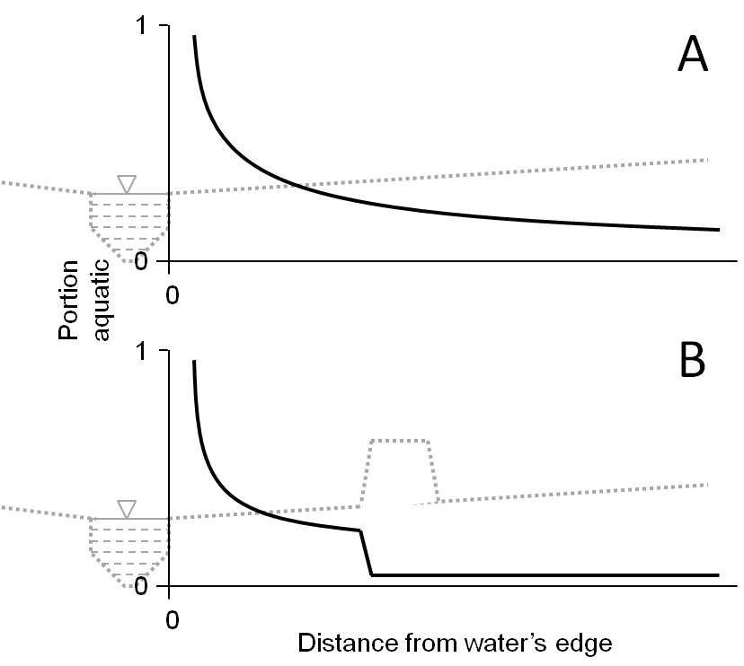

## Fig. 1.

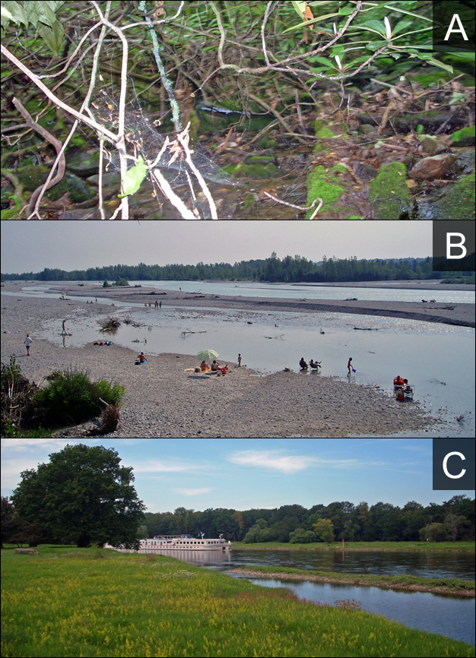

## Fig. 2.

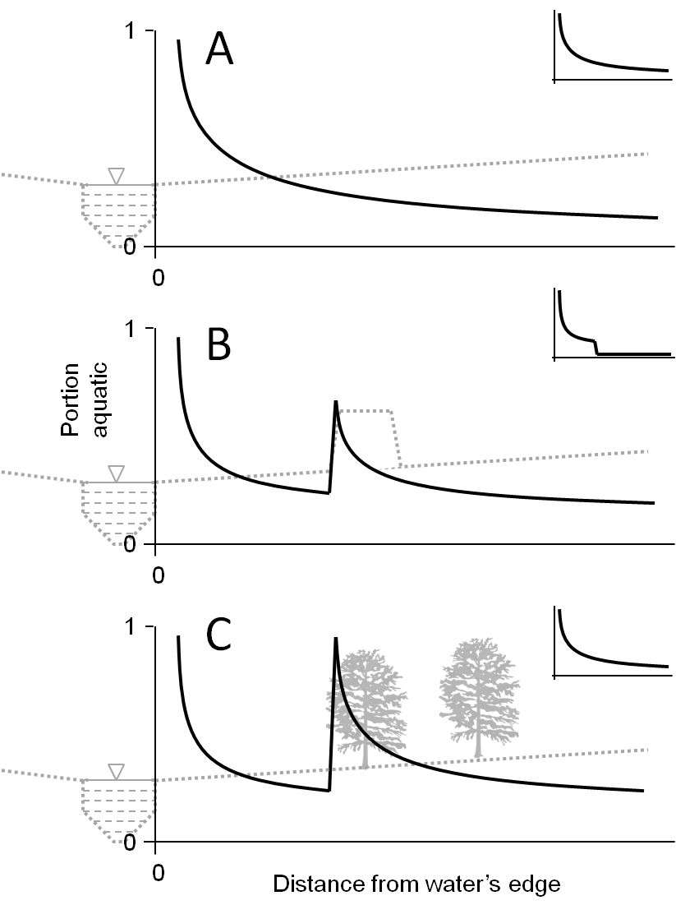

Fig. 3.

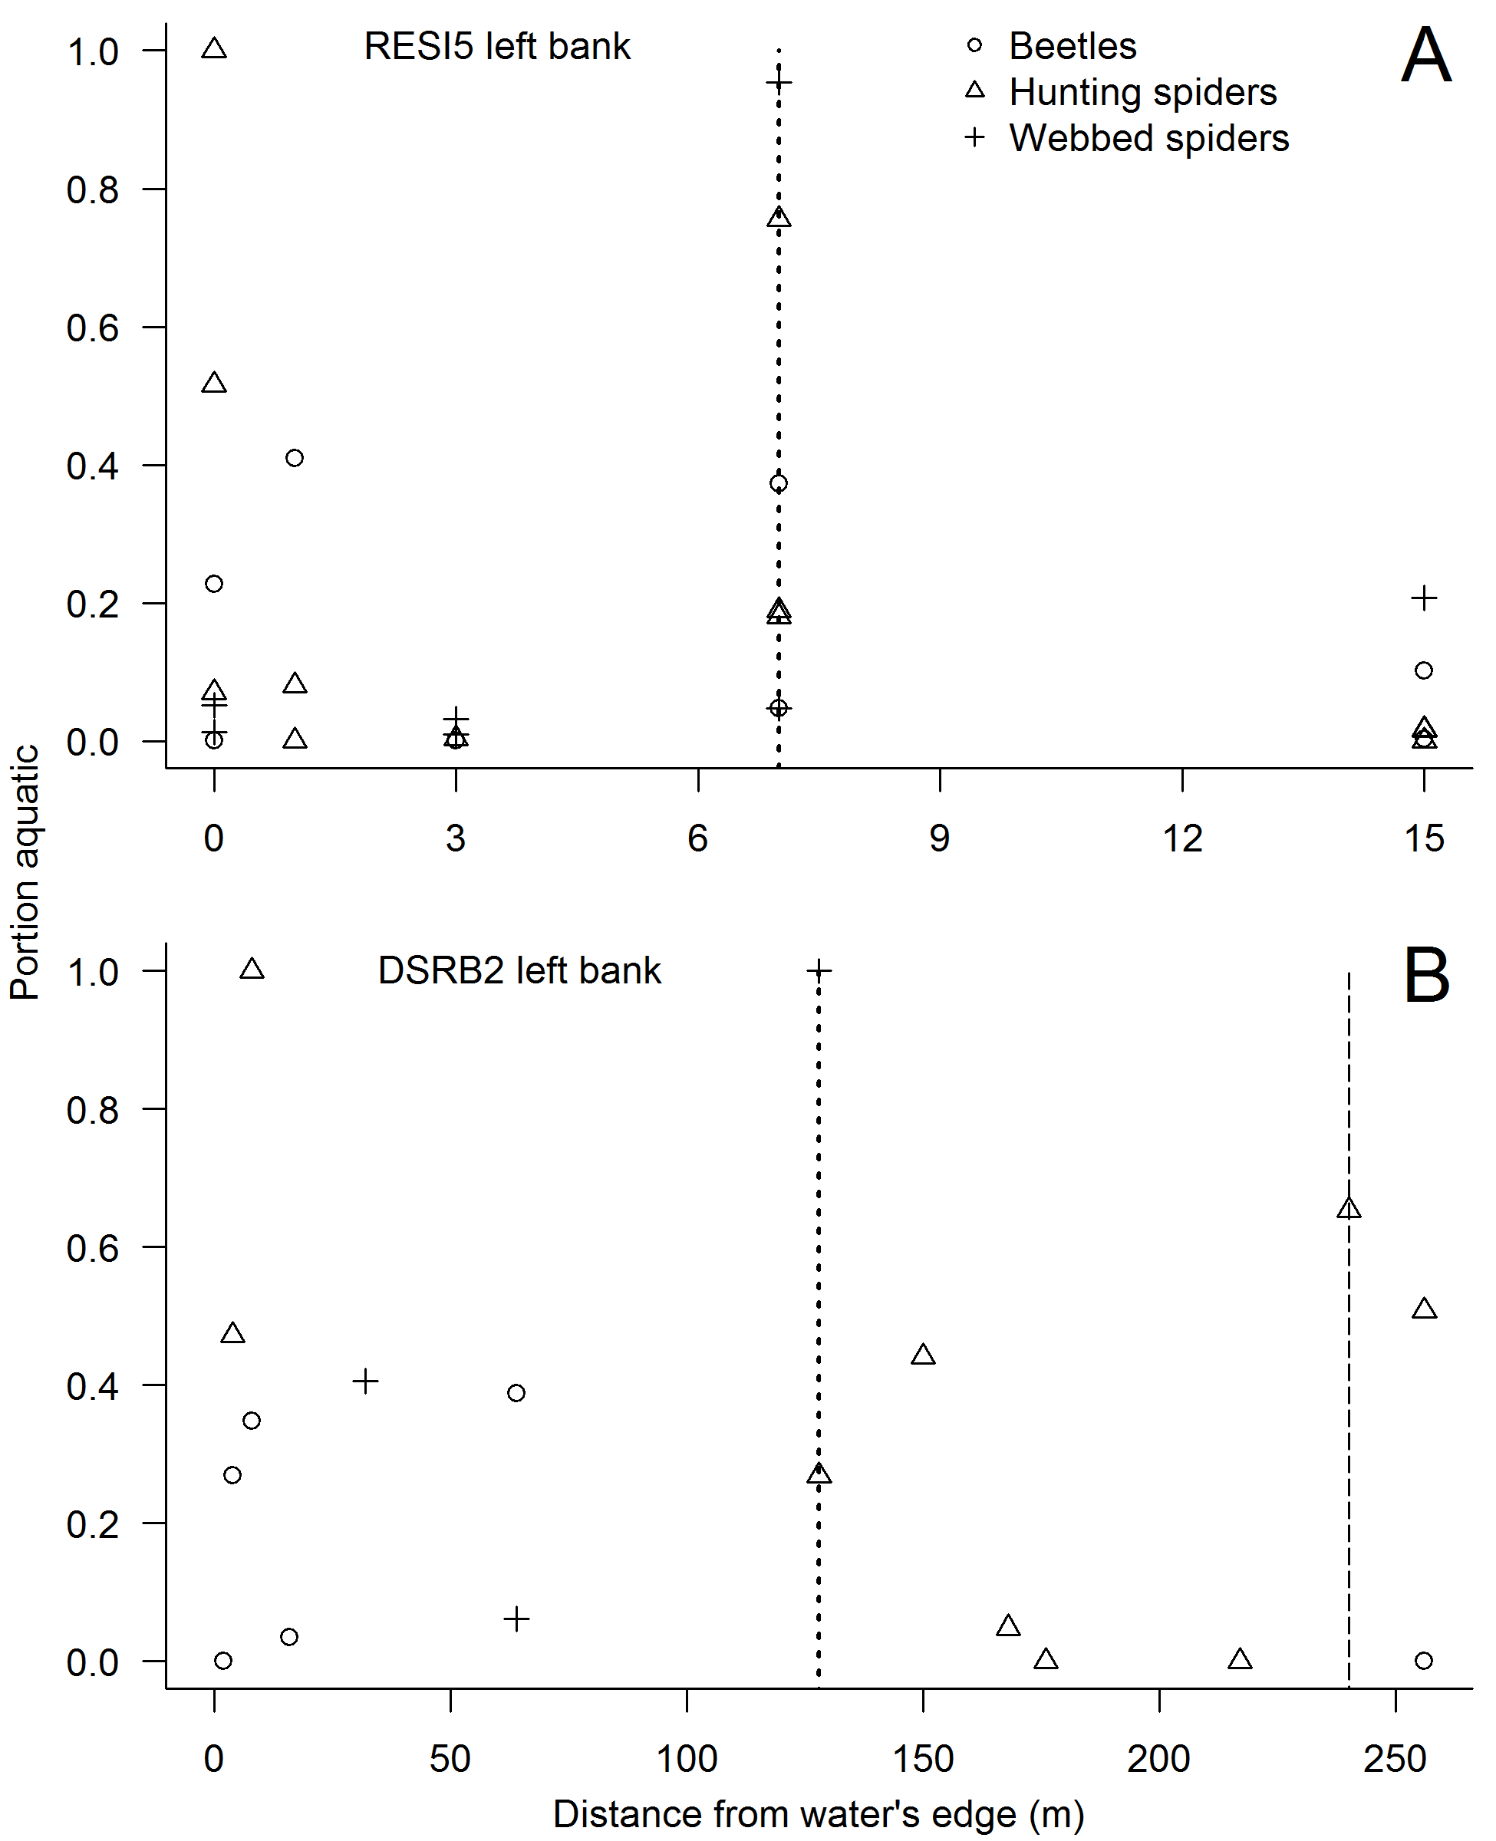

Fig. 4.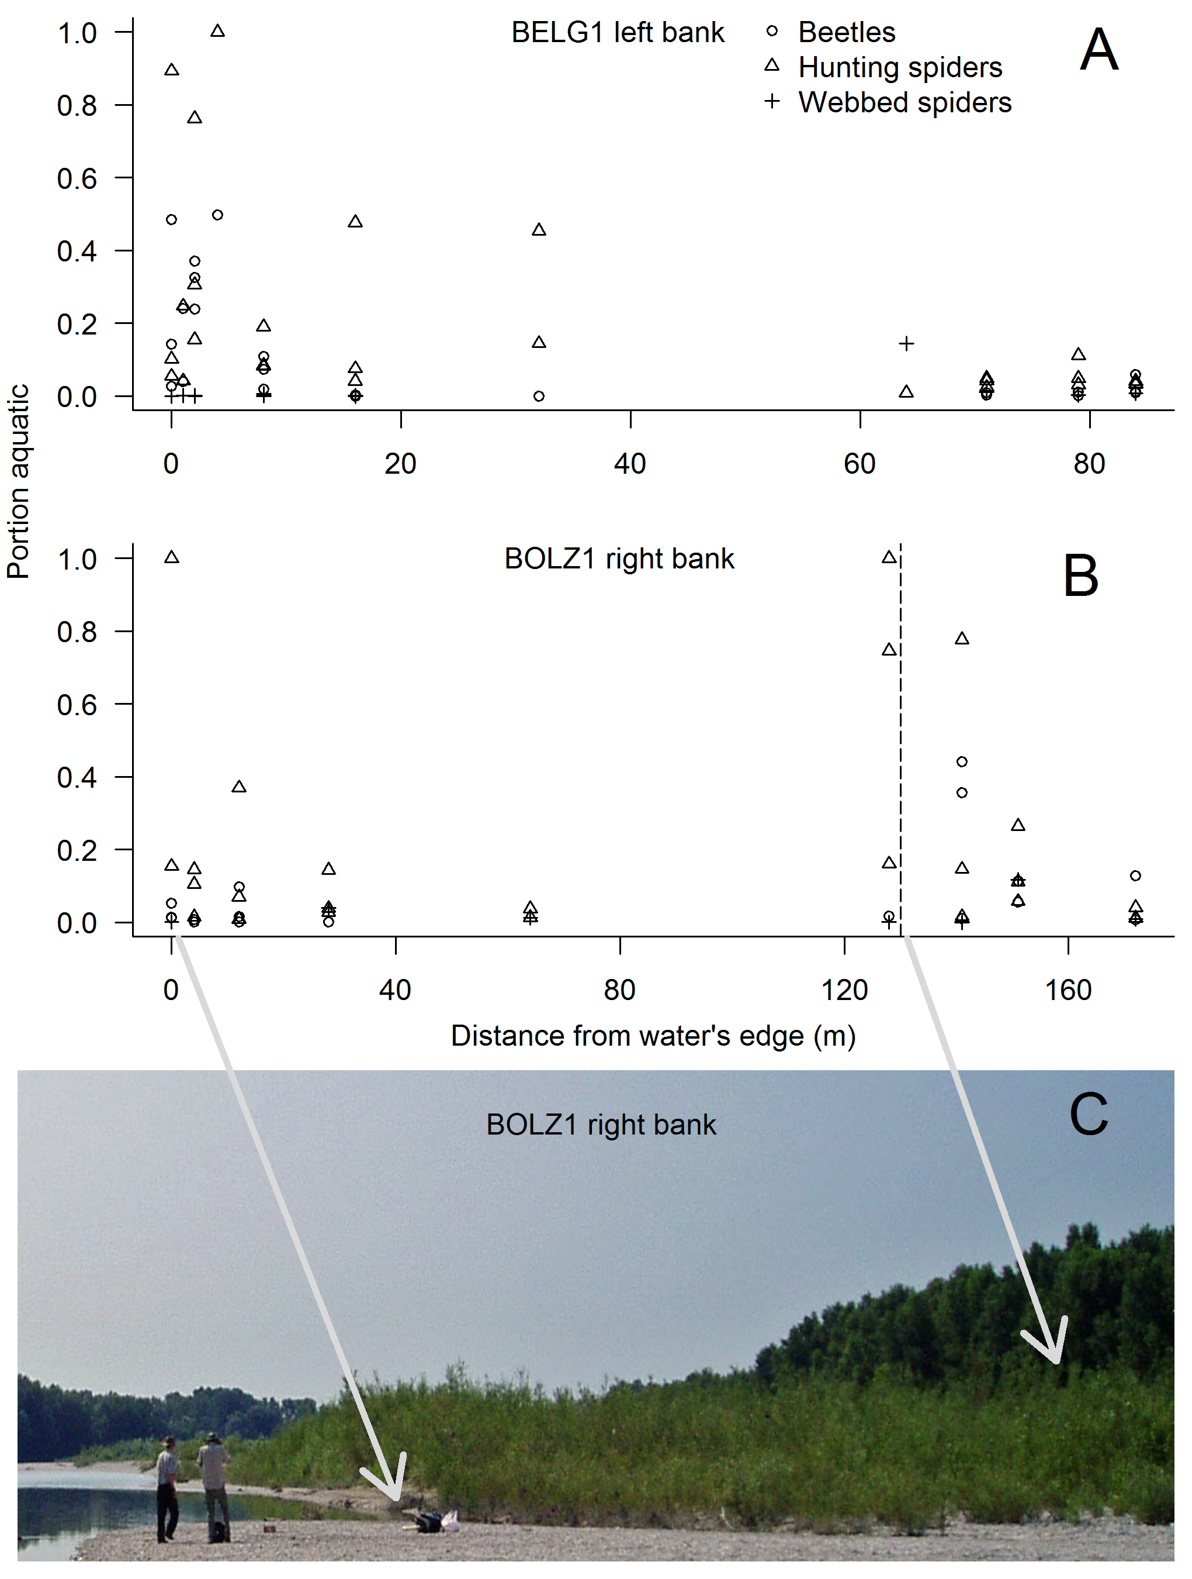

Fig. 5.

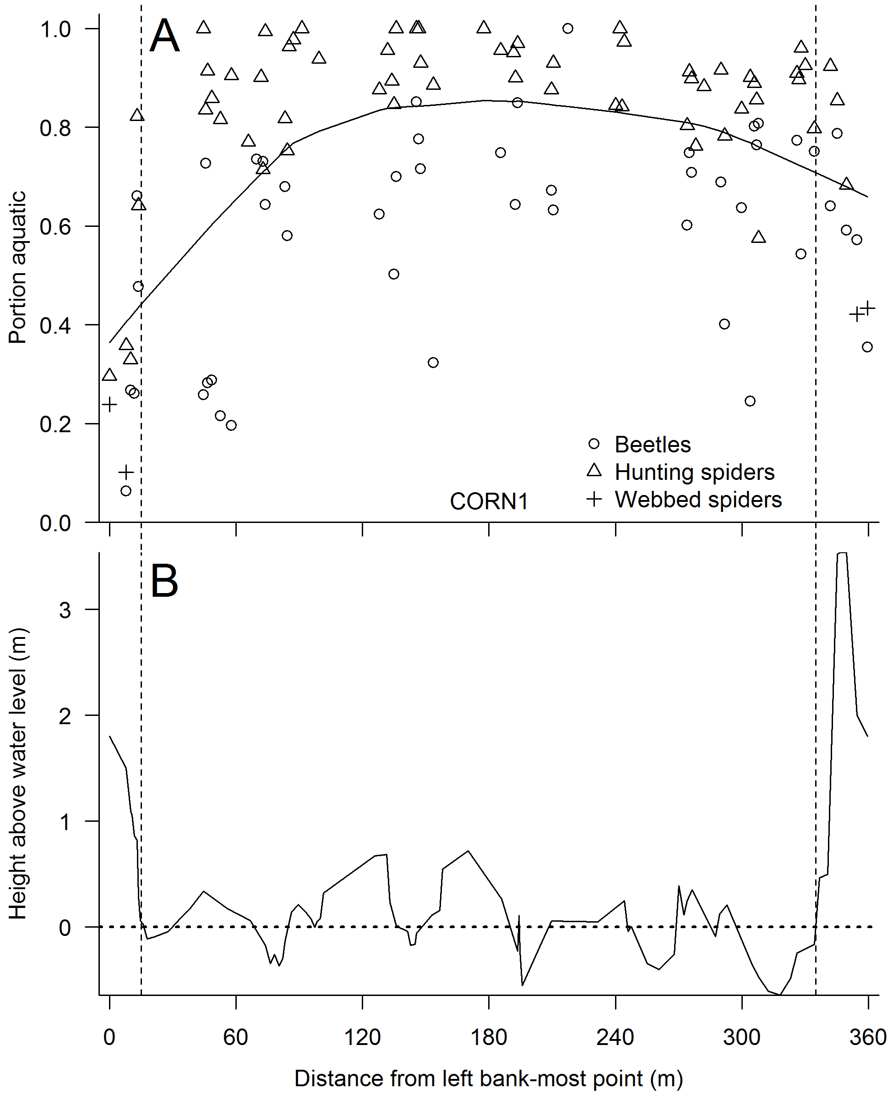

## Fig. 6.

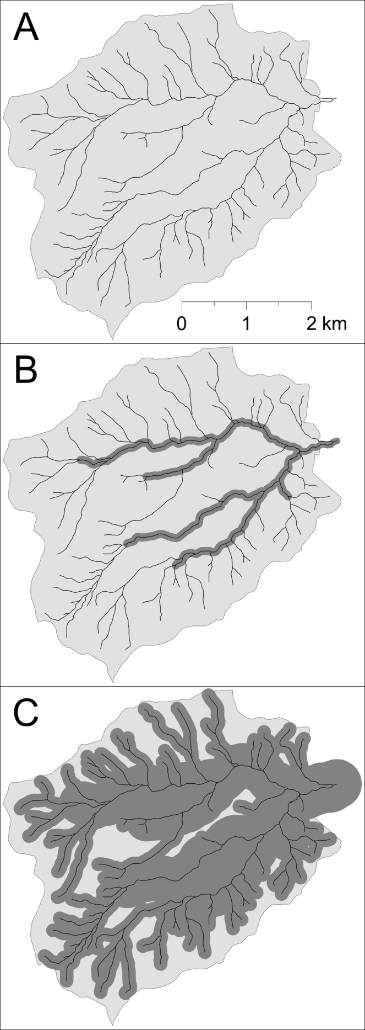

Fig. 7.

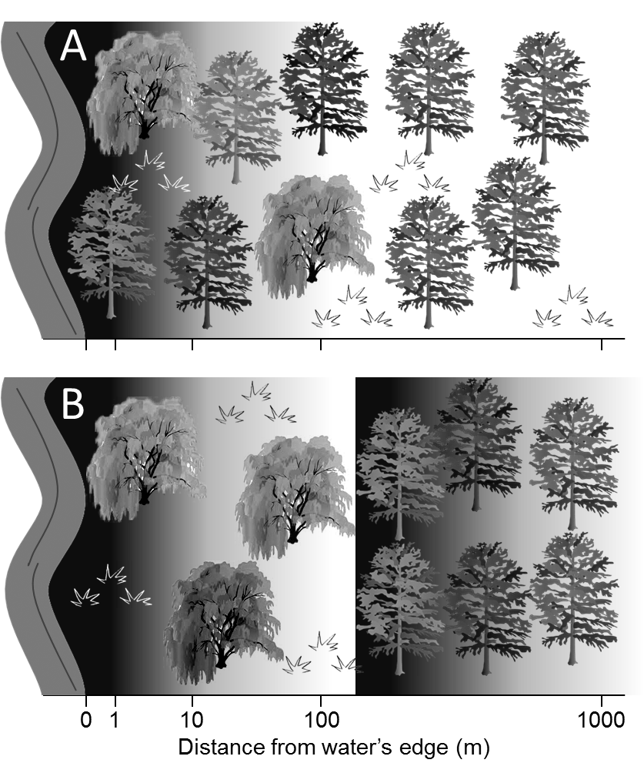

Fig. 8.

Appendix A. Site descriptions and photos, and arthropod group designations used in this study.

Table A1. Descriptions of the 46 sites used in this study, including in-channel, bank, floodplain/riparian, and upland physical and biological characteristics.

|  |  |  |  |  |  |  |  |  |
| --- | --- | --- | --- | --- | --- | --- | --- | --- |
| Site | Bank | Study region | Channel width (m) | Stream order | Channel geomorphology | Bank type | Floodplain vegetation | Upland vegetation |
| BATE1 | Left | Coweeta | 2 | 1-2 | Straight | Gradual | Overstory | Overstory |
| BATE1 | Right | Coweeta | 2 | 1-2 | Straight | Gradual | Overstory | Overstory |
| HEAD2 | Left | Coweeta | 4 | 1-2 | Meandering | Steep | Overstory | Overstory |
| HEAD2 | Right | Coweeta | 4 | 1-2 | Meandering | Steep | Overstory | Overstory |
| BALL1 | Left | Coweeta | 5 | 3-4 | Meandering | Gradual | Overstory | Overstory |
| BALL1 | Right | Coweeta | 5 | 3-4 | Meandering | Steep | Overstory | Overstory |
| COWE1 | Left | Coweeta | 6 | 3-4 | Meandering | Gradual | Overstory | Overstory |
| COWE1 | Right | Coweeta | 6 | 3-4 | Meandering | Gradual | Overstory | Overstory |
| LTEN1 | Right | Coweeta | 21 | 5-6 | Meandering | Gradual | Overstory | Understory |
| RESI3 | Left | Tagliamento | 3 | 1-2 | Meandering | Steep | Overstory | Overstory |
| RESI3 | Right | Tagliamento | 3 | 1-2 | Meandering | Steep | Overstory | Overstory |
| RESI4 | Left | Tagliamento | 4 | 1-2 | Straight | Steep | Understory | Understory |
| RESI4 | Right | Tagliamento | 4 | 1-2 | Straight | Steep | Understory | Understory |
| RESI2 | Left | Tagliamento | 5 | 1-2 | Straight | Gradual | Understory | Overstory |
| RESI2 | Right | Tagliamento | 5 | 1-2 | Straight | Gradual | Understory | Overstory |
| RESI1 | Left | Tagliamento | 7 | 3-4 | Braided | Steep | Barren | Understory |
| RESI1 | Right | Tagliamento | 7 | 3-4 | Braided | Gradual | Overstory | Overstory |
| RESI5 | Left | Tagliamento | 16 | 3-4 | Braided | Terrace | Understory | Overstory |
| RESI5 | Right | Tagliamento | 16 | 3-4 | Braided | Gradual | Barren | Understory |
| ARZO1 | Left | Tagliamento | 22 | 3-4 | Meandering | Gradual | Understory | Overstory |
| ARZO1 | Right | Tagliamento | 22 | 3-4 | Meandering | Gradual | Understory | Overstory |

Table A1. Continued (bottom of table).

|  |  |  |  |  |  |  |  |  |
| --- | --- | --- | --- | --- | --- | --- | --- | --- |
| Site | Bank | Study region | Channel width (m) | Stream order | Channel geomorphology | Bank type | Floodplain vegetation | Upland vegetation |
| ARZO2 | Left | Tagliamento | 26 | 3-4 | Meandering | Terrace | Understory | Overstory |
| BOLZ1 | Left | Tagliamento | 38 | 5-6 | Meandering | Steep | Overstory | Overstory |
| BOLZ1 | Right | Tagliamento | 38 | 5-6 | Meandering | Gradual | Understory | Overstory |
| BELG1 | Left | Tagliamento | 72 | 5-6 | Meandering | Gradual | Barren | Overstory |
| BELG1 | Right | Tagliamento | 72 | 5-6 | Meandering | Terrace | Overstory | Understory |
| FELL1 | Right | Tagliamento | 101 | 5-6 | Braided | Levee | Barren | Overstory |
| CORN1 | Left | Tagliamento | 312 | 5-6 | Braided | Gradual | Barren | Overstory |
| CORN1 | Right | Tagliamento | 312 | 5-6 | Braided | Terrace | Barren | Overstory |
| BECH1 | Right | Tagliamento | 400 | 5-6 | Braided | Gradual | Barren | Overstory |
| BECH2 | Right | Tagliamento | 400 | 5-6 | Braided | Terrace | Barren | Overstory |
| ISLA1 | Left | Tagliamento | 411 | 5-6 | Braided | Steep | Barren | Overstory |
| ISLA1 | Right | Tagliamento | 411 | 5-6 | Braided | Gradual | Barren | Overstory |
| DRAV1 | Left | Danube | 150 | 5-6 | Straight | Terrace | Understory | Overstory |
| DSRB3 | Left | Danube | 400 | 7+ | Straight | Gradual | Overstory | Understory |
| DSRB4 | Left | Danube | 400 | 7+ | Meandering | Terrace | Understory | Overstory |
| DANU1 | Right | Danube | 450 | 7+ | Point bars | Gradual | Barren | Overstory |
| DANU2 | Right | Danube | 450 | 7+ | Point bars | Levee | Barren | Overstory |
| SAVA1 | Left | Danube | 450 | 7+ | Meandering | Gradual | Overstory | Overstory |
| DFOR1 | Right | Danube | 500 | 7+ | Straight | Terrace | Barren | Overstory |
| DMDW1 | Right | Danube | 500 | 7+ | Straight | Terrace | Barren | Understory |
| DSRB1 | Left | Danube | 600 | 7+ | Straight | Levee | Understory | Overstory |
| DSRB2 | Left | Danube | 600 | 7+ | Meandering | Levee | Overstory | Understory |
| ELBE1 | Left | Elbe | 200 | 7+ | Point bars | Terrace | Barren | Understory |
| ELBE2 | Left | Elbe | 200 | 7+ | Meandering | Terrace | Barren | Understory |
| ELBE3 | Right | Elbe | 200 | 7+ | Meandering | Gradual | Understory | Overstory |

Table A1. Continued (top of right-most column).

|  |  |  |
| --- | --- | --- |
| Site | Bank | Location |
| BATE1 | Left | Bates Branch at Coweeta LTER, USA |
| BATE1 | Right | Bates Branch at Coweeta LTER, USA |
| HEAD2 | Left | Tributary of Shope Fork Creek at Coweeta LTER, USA |
| HEAD2 | Right | Tributary of Shope Fork Creek at Coweeta LTER, USA |
| BALL1 | Left | Ball Creek at Coweeta LTER, USA |
| BALL1 | Right | Ball Creek at Coweeta LTER, USA |
| COWE1 | Left | Coweeta Creek at Coweeta LTER, USA |
| COWE1 | Right | Coweeta Creek at Coweeta LTER, USA |
| LTEN1 | Right | Little Tennessee River near Franklin, North Carolina, USA |
| RESI3 | Left | Tributary of Resia River near Coritis, Italy |
| RESI3 | Right | Tributary of Resia River near Coritis, Italy |
| RESI4 | Left | Tributary of Resia River near Oseacco, Italy |
| RESI4 | Right | Tributary of Resia River near Oseacco, Italy |
| RESI2 | Left | Tributary of Resia River near Oseacco, Italy |
| RESI2 | Right | Tributary of Resia River near Oseacco, Italy |
| RESI1 | Left | Resia River near Stolvizza, Italy |
| RESI1 | Right | Resia River near Stolvizza, Italy |
| RESI5 | Left | Resia River near Oseacco, Italy |
| RESI5 | Right | Resia River near Oseacco, Italy |
| ARZO1 | Left | Arzino River near Flagogna, Italy |
| ARZO1 | Right | Arzino River near Flagogna, Italy |

Table A1. Continued (bottom of right-most column).

|  |  |  |
| --- | --- | --- |
| Site | Bank | Location |
| ARZO2 | Left | Arzino River near Flagogna, Italy |
| BOLZ1 | Left | Tagliamento River near Valvasone, Italy |
| BOLZ1 | Right | Tagliamento River near Valvasone, Italy |
| BELG1 | Left | Tagliamento River near Belgrado, Italy |
| BELG1 | Right | Tagliamento River near Belgrado, Italy |
| FELL1 | Right | Fella River near Moggio Udinese, Italy |
| CORN1 | Left | Tagliamento River near Cornino, Italy |
| CORN1 | Right | Tagliamento River near Cornino, Italy |
| BECH1 | Right | Tagliamento River near Ragogna, Italy |
| BECH2 | Right | Tagliamento River near Ragogna, Italy |
| ISLA1 | Left | Tagliamento River near Pinzano, Italy |
| ISLA1 | Right | Tagliamento River near Pinzano, Italy |
| DRAV1 | Left | Drava River near Őrtilos, Hungary |
| DSRB3 | Left | Danube River near Apatin, Serbia |
| DSRB4 | Left | Danube River near Apatin, Serbia |
| DANU1 | Right | Danube River near Orth, Austria |
| DANU2 | Right | Danube River near Orth, Austria |
| SAVA1 | Left | Sava River in Obedska Bara Nature Reserve, Serbia |
| DFOR1 | Right | Danube River near Mohács, Hungary |
| DMDW1 | Right | Danube River near Mohács, Hungary |
| DSRB1 | Left | Danube River near Bački Monoštor, Serbia |
| DSRB2 | Left | Danube River near Bački Monoštor, Serbia |
| ELBE1 | Left | Elbe River near Dessau, Germany |
| ELBE2 | Left | Elbe River near Dessau, Germany |
| ELBE3 | Right | Elbe River near Dessau, Germany |

Table A2. Major groupings of arthropods, which were analyzed separately for biomass at each sampling location. With the exception of groups labeled “miscellaneous others,” the remaining 14 groups, when present at a location, were used for stable isotope analysis.

|  |  |
| --- | --- |
| Major group | Predominant or characteristic families |
| Aerial aquatic |  |
| Diptera | Chironomidae, Tipulidae |
| Ephemeroptera | Heptageniidae, Baetidae, Ephemerellidae |
| Odonata | Coenagrionidae |
| Plecoptera | Leuctridae, Pteronarcyidae, Perlidae |
| Trichoptera | Hydropsychidae, Limnephilidae |
| Aquatic larvae |  |
| Ephemeroptera | Heptageniidae, Baetidae, Ephemerellidae |
| Plecoptera | Leuctridae, Pteronarcyidae, Perlidae |
| Trichoptera | Hydropsychidae, Limnephilidae |
| Miscellaneous others | Various |
| Predaceous terrestrial |  |
| Coleoptera | Carabidae, Staphylinidae |
| Arachnida, hunting | Lycosidae, Clubionidae, Amaurobiidae |
| Arachnida, webbed | Araneidae, Linyphiidae, Tetragnathidae |
| Herbivorous terrestrial |  |
| Lepidoptera larvae | Various caterpillars |
| Hemiptera | Cicadellidae, Cercopidae, Delphacidae |
| Miscellaneous terrestrial |  |
| Lepidoptera adults | Various butterflies and moths |
| Miscellaneous others | Various |

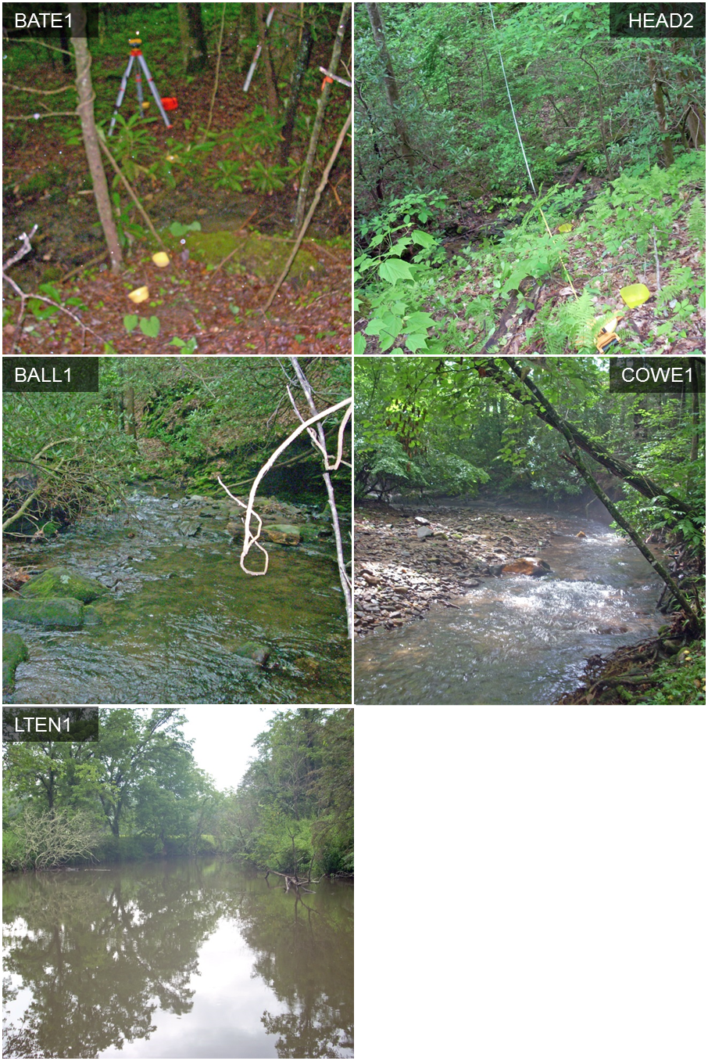

Fig A1 continued (see legend at bottom of figure).

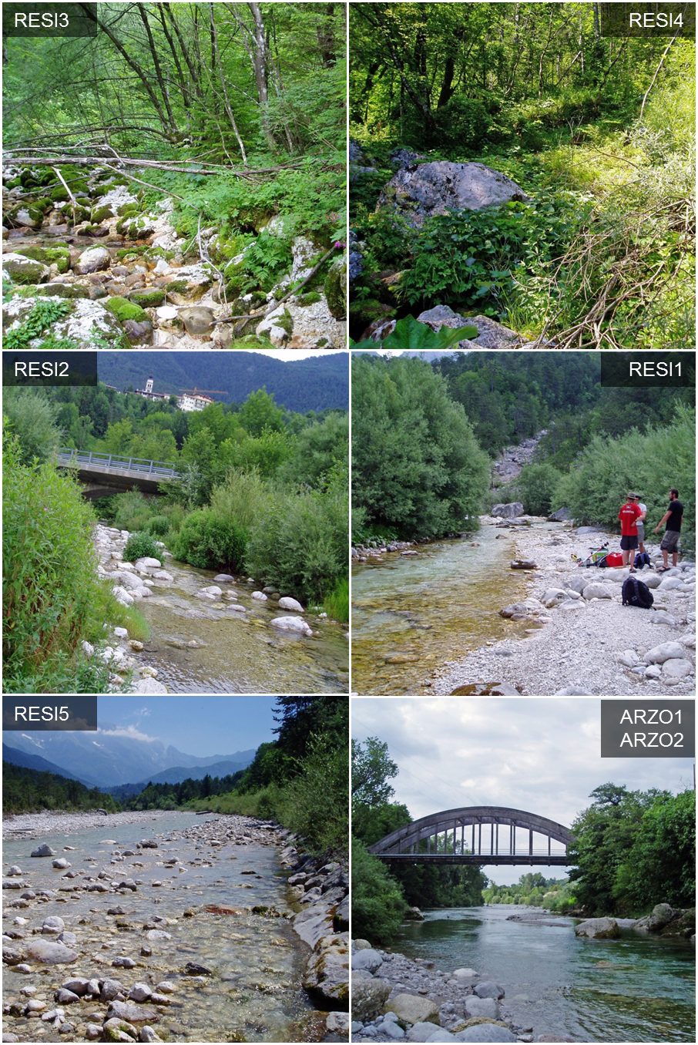

Fig A1 continued (see legend at bottom of figure).

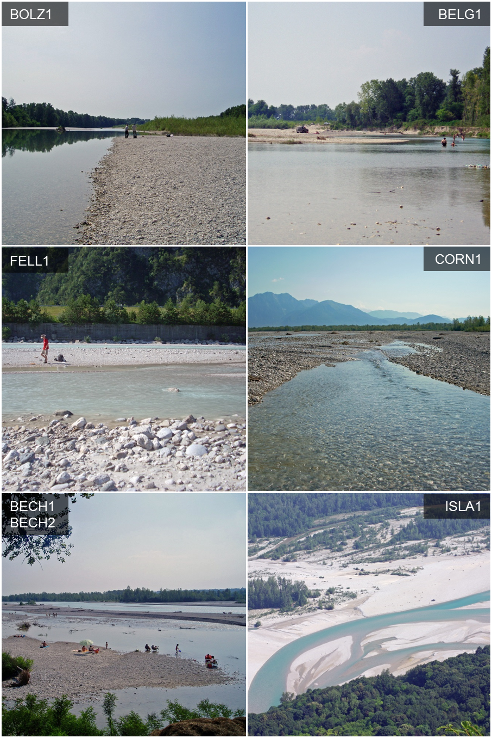

Fig A1 continued (see legend at bottom of figure).

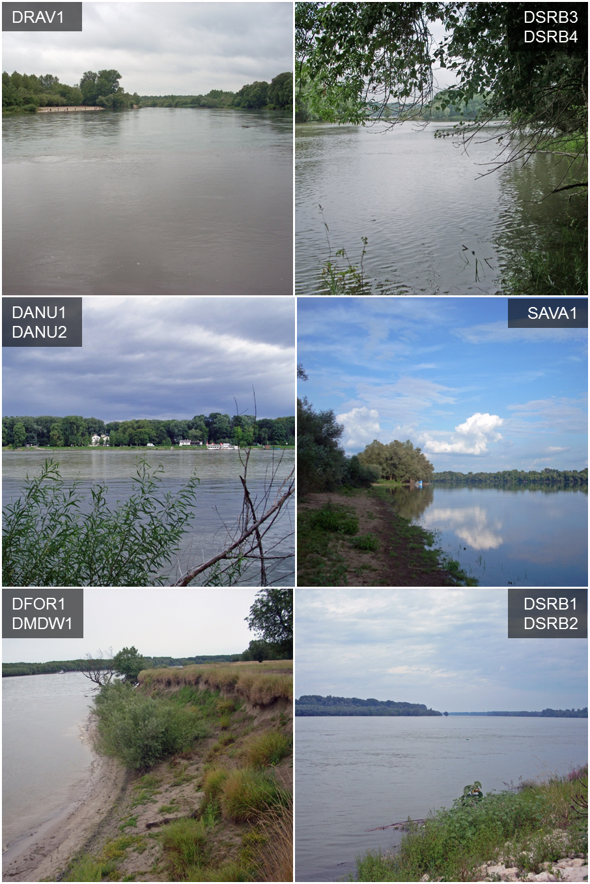

Fig A1 continued (see legend at bottom of figure).

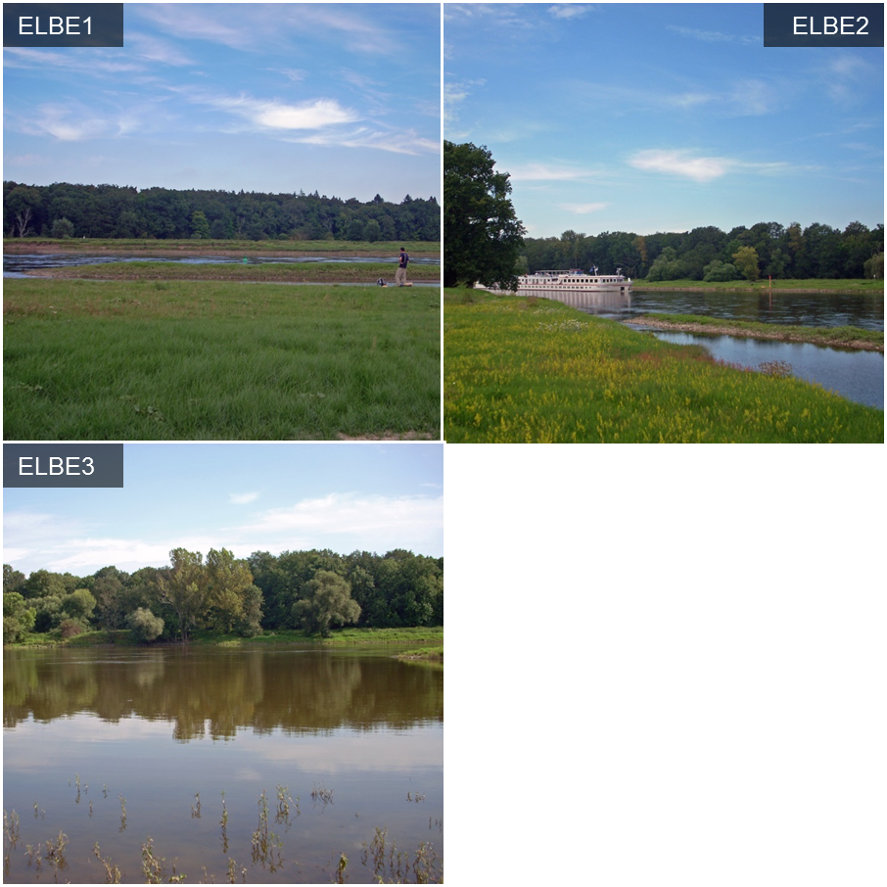

Fig. A1. Photographs of sites used in this study, to provide a sense of scale of the differences between sites. Site names in the top corners of each photo correspond to names in Table A1. In instances where two sites are listed for a given photo, no representative photos of the exact sites existed, so the scene depicted is of the general area within ~ 1 km of the both sites.

Appendix B. Supporting figures for curve fitting and light trap catch data.

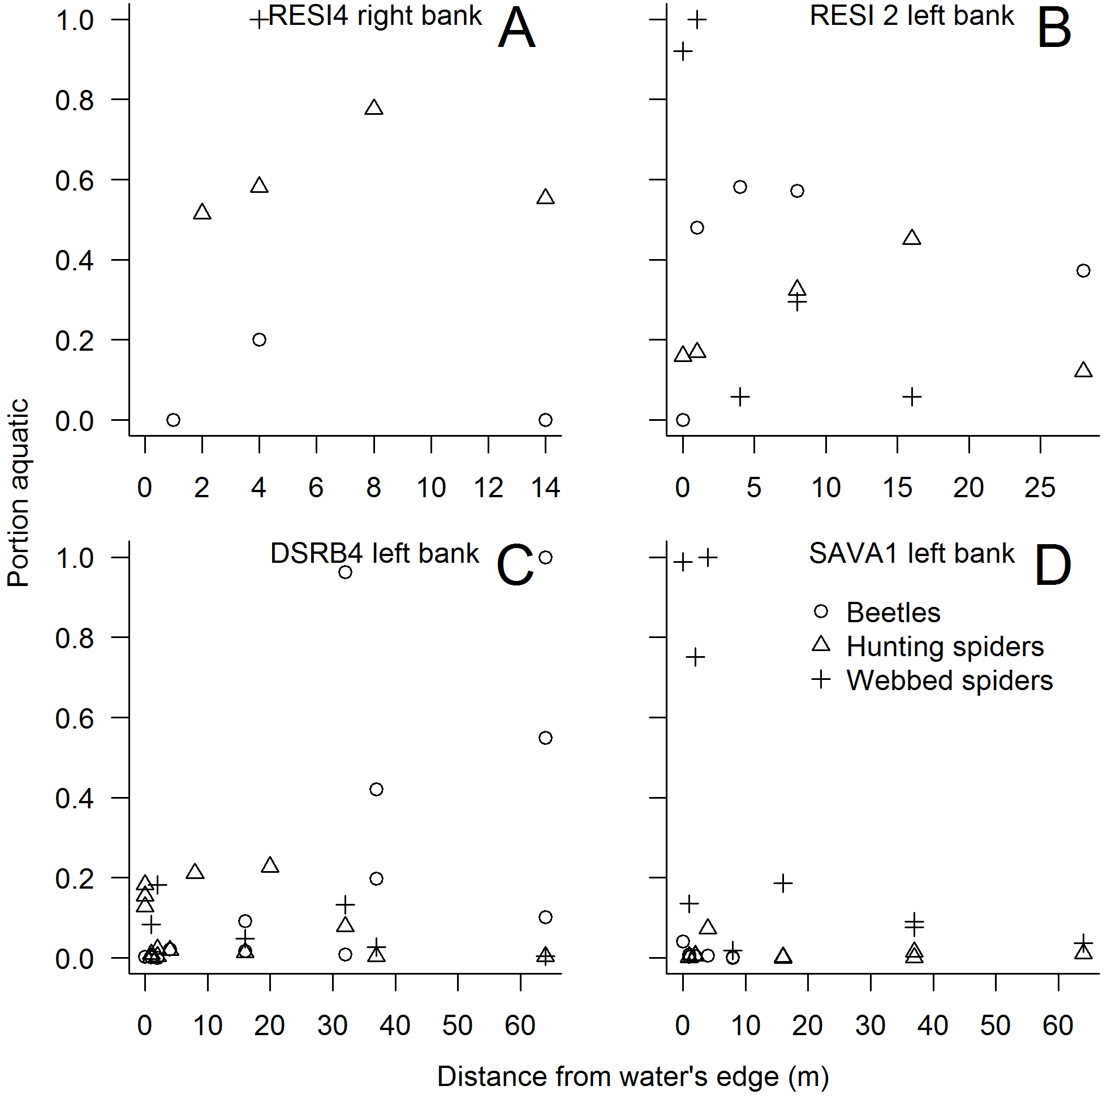

Fig. B1. Example study sites where subsidy–distance decay curves to compute stream signatures could not be fit (A, C), contrasted with sites with similar conditions where curves were fit (B, D). Panels A and B are based on stable isotope data; C and D are based on predator abundance*biomass data. A and B are headwater stream sites in the Resia River catchment in NE Italy; C and D are sites on the large Danube and Sava Rivers in Serbia, respectively.

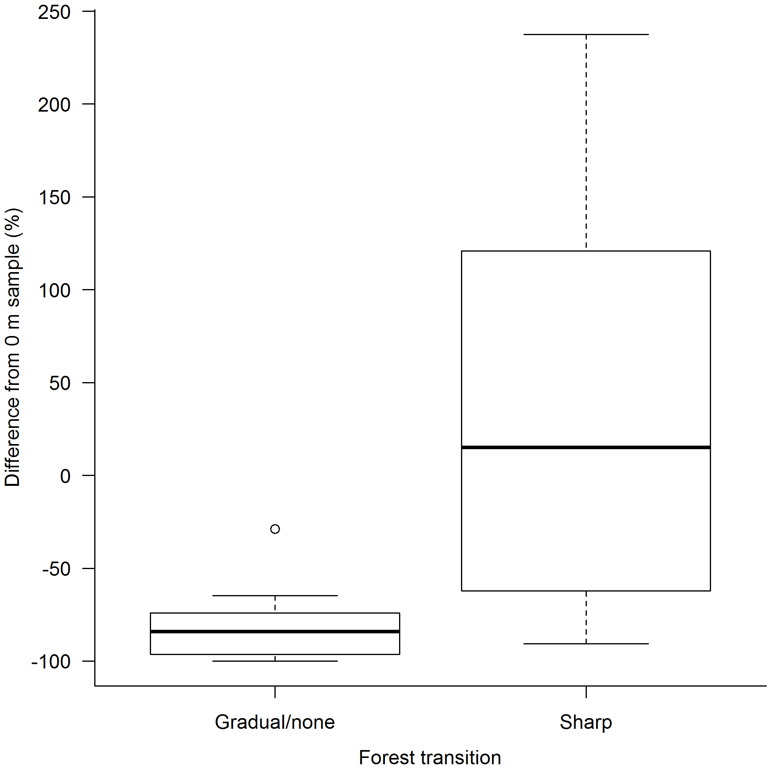

Fig. B2. Abundance*biomass of adult macroinvertebrates collected at the farthest sampling distance from the stream at each site during night light trap sampling. Data are expressed as a percentage relative to the abundance*biomass caught in paired traps set at the water’s edge. Sites are grouped according to the presence or absence of distinct breaks between riparian and upland vegetation. Bold horizontal lines are median values, box edges are 25th and 75th percentiles, and line segment edges are 10th and 90th percentiles.

Appendix C. Model comparison tables for parameters included in the best, overall stream signature prediction models for predator attraction and food webs.

Table C1. Stream signature model comparison for predator attraction effect. Asterisk (*) and plus (+) symbols indicate factors added to both the model slope and intercept or to the intercept only, respectively.

|  |  |  |  |  |  |  |  |  |  |  |  |
| --- | --- | --- | --- | --- | --- | --- | --- | --- | --- | --- | --- |
| Model | Study region | Stream order | Channel geomorphology | Bank type | Floodplain vegetation | Predator group | Adjusted R2 | df | AICc | i | Weight |
| 1 | * | + |  |  | + | * | 0.2492 | 19 | 1729.1 | 0.0 | 0.086 |
| 2 | + | + |  |  | + | * | 0.2416 | 16 | 1729.2 | 0.1 | 0.082 |
| 3 | + | * |  |  | + | * | 0.2491 | 19 | 1729.2 | 0.1 | 0.081 |
| 4 | * | + | + |  | + | * | 0.2560 | 22 | 1729.7 | 0.6 | 0.064 |
| 5 | * | + | + |  |  | * | 0.2499 | 20 | 1730.6 | 1.6 | 0.039 |
| 6 | + | * | + |  | + | * | 0.2549 | 22 | 1730.7 | 1.6 | 0.039 |
| 7 | + | + | + |  | + | * | 0.2469 | 19 | 1731.0 | 1.9 | 0.033 |
| 8 | * | + |  | + | + | * | 0.2539 | 22 | 1731.4 | 2.4 | 0.026 |
| 9 | * | + | + | + | + | * | 0.2612 | 25 | 1731.7 | 2.6 | 0.023 |
| 10 | + | * |  | + | + | * | 0.2536 | 22 | 1731.8 | 2.7 | 0.022 |
| 11 | + | + |  | + | + | * | 0.2459 | 19 | 1731.8 | 2.8 | 0.021 |
| 12 | + | + |  |  | + | + | 0.2330 | 14 | 1732.2 | 3.1 | 0.018 |
| 13 | + | + |  |  | * | * | 0.2430 | 18 | 1732.2 | 3.2 | 0.018 |
| 14 | + | * |  |  | + | + | 0.2402 | 17 | 1732.4 | 3.4 | 0.016 |
| 15 | + | * | + |  |  | * | 0.2476 | 20 | 1732.6 | 3.5 | 0.015 |
| 16 | * | + | + | + |  | * | 0.2551 | 23 | 1732.6 | 3.5 | 0.015 |
| 17 | + | + |  | * | + | * | 0.2525 | 22 | 1732.7 | 3.6 | 0.014 |
| 18 | * | + |  |  | + | + | 0.2399 | 17 | 1732.7 | 3.7 | 0.014 |
| 19 | + | * | + | + | + | * | 0.2599 | 25 | 1732.8 | 3.7 | 0.014 |
| 20 | * | + |  |  | * | * | 0.2497 | 21 | 1732.9 | 3.8 | 0.013 |
| 21 | + | + | + | * | + | * | 0.2597 | 25 | 1732.9 | 3.9 | 0.013 |
| 22 | * | + | + |  | + | + | 0.2471 | 20 | 1733.0 | 3.9 | 0.012 |
| Sums: | 22 | 22 | 10 | 8 | 19 | 22 |  |  |  |  |  |
| % of models: | 100% | 100% | 45% | 36% | 86% | 100% |  |  |  |  |  |

Table C2. Stream signature model comparison for food web (stable isotope) effect. Asterisk (*) and plus (+) symbols indicate factors added to both the model slope and intercept or to the intercept only, respectively.

|  |  |  |  |  |  |  |  |  |  |  |  |
| --- | --- | --- | --- | --- | --- | --- | --- | --- | --- | --- | --- |
| Model | Study region | Stream order | Channel geomorphology | Bank type | Floodplain vegetation | Predator group | Adjusted R2 | df | AICc | i | Weight |
| 1 |  |  |  |  | + |  | 0.3128 | 6 | 716.4 | 0.0 | 0.136 |
| 2 |  | + |  |  |  |  | 0.3145 | 7 | 717.9 | 1.5 | 0.065 |
| 3 | * |  | + | + | + |  | 0.3714 | 17 | 718.4 | 2.0 | 0.051 |
| 4 | + |  | + | + | + |  | 0.3537 | 14 | 718.5 | 2.1 | 0.048 |
| 5 | + |  |  |  | + |  | 0.3245 | 9 | 718.5 | 2.1 | 0.048 |
| 6 | * |  |  |  | + |  | 0.3413 | 12 | 718.8 | 2.4 | 0.042 |
| 7 |  |  |  | + | + |  | 0.3167 | 8 | 719.3 | 2.8 | 0.033 |
| 8 |  |  |  | + |  |  | 0.3049 | 6 | 719.3 | 2.9 | 0.033 |
| 9 |  | + |  |  | + |  | 0.3220 | 9 | 719.5 | 3.0 | 0.030 |
| 10 |  |  |  |  |  |  | 0.2917 | 4 | 719.8 | 3.4 | 0.025 |
| 11 |  | + |  | + |  |  | 0.3207 | 9 | 719.9 | 3.5 | 0.024 |
| 12 |  |  |  |  | * |  | 0.3145 | 8 | 720.1 | 3.6 | 0.022 |
| 13 | + |  | + |  | + |  | 0.3371 | 12 | 720.4 | 4.0 | 0.019 |
| 14 |  |  |  |  | + | + | 0.3136 | 8 | 720.4 | 4.0 | 0.019 |
| Sums: | 5 | 3 | 3 | 5 | 10 | 1 |  |  |  |  |  |
| % of models: | 36% | 21% | 21% | 36% | 71% | 7% |  |  |  |  |  |